Digital Marketing Automation System using n8n
Final Year Project
Session 2022-2026

A project submitted in partial fulfillment of the degree of
BS in Information Technology


Department of Information Technology
Faculty of Computer Science & Information Technology
The Superior University, Lahore
Fall 2025

Type (Nature of project) |  |  | [ ✔ ] Development [ ] Research [ ] R&D
Area of specialization
FYP ID |  |  | SU92-BSITM-F25-022
Project Group Members
Sr.# | Reg. # | Student Name |  | Email ID | *Signature
(i) |  | Talha Younas |  | SU92-BSITM-F22-093
(ii) |  | Ihsan Ali |  | SU92-BSITM-F22-106
(iii)
*The candidates confirm that the work submitted is their own and appropriate credit has been given where reference has been made to work of others

Plagiarism Free Certificate
This is to certify that, I Talha Younas S/D of Muhammad Younas Akhtar, group leader of FYP under registration no SU92-BSITM-F25-022 at Information Technology Department, The Superior University, Lahore. I declare that my FYP report is checked by my supervisor.

Date: Name of Group Leader: Talha Younas Signature: _____________
Name of Supervisor: Uns Bin Younas Co-Supervisor: Mr. XYZ
Designation: Senior Lecturer Designation: Associate Professor
Signature: ________________ Signature: _________________

HoD: Dr. Gohar Mumtaz
Signature: _______________

AutoMarketer

Change Record

Author(s) | Version | Date | Notes | Sig.
Talha Younas | 1.0 | 15 Jan 2026 | Initial draft completed including introduction, background, motivations, goals, and preliminary objectives.
Talha Younas | 1.1 | 28 Jan 2026 | Revised problem statement and scope per supervisor feedback; narrowed AI workflow focus and corrected architecture diagram.
Ihsan Ali | 1.2 | 12 Feb 2026 | Expanded literature review with critical analysis of existing solutions; added citations for HubSpot, Salesforce Einstein, and Persado.
Ihsan Ali | 1.3 | 05 Mar 2026 | Added complete project plan including Work Breakdown Structure, Gantt chart, roles matrix, and empathy map.
Talha Younas | 1.4 | 22 Mar 2026 | Revised system design and use case diagrams based on supervisor feedback; updated ERD and class diagram.
Talha Younas | 2.0 | 10 Apr 2026 | Final draft incorporating all faculty and supervisor revisions; proofread and formatted for submission.

APPROVAL
PROJECT SUPERVISOR
Comments: ___________________________________________________________________
_____________________________________________________________________________
Name:______________________________
Date:_______________________________ | Signature:__________________________

PROJECT MANAGER
Comments: ___________________________________________________________________
_____________________________________________________________________________
Date:_______________________________ | Signature:__________________________

HEAD OF THE DEPARTMENT
Comments: ___________________________________________________________________
_____________________________________________________________________________
Date:_______________________________ | Signature:__________________________

Dedication

This work is dedicated to my UNS BIN YOUNAS We dedicate this project to our beloved families, teachers, and mentors. Their continuous support, encouragement, and prayers have been our source of strength. Without their guidance and love, this achievement would not have been possible.

Acknowledgements

I am really thankful to my supervisor who has UNS BIN YOUNAS we would like to express our deepest gratitude to our supervisor, whose valuable guidance and constructive feedback helped us throughout this project. We also thank The Superior University, Lahore, for providing us with the opportunity and resources to pursue this work. Finally, we extend appreciation to our peers and friends for their encouragement and support during difficult times.

Executive Summary
In today’s business landscape, digital marketing plays a vital role in reaching customers, promoting products, and strengthening brand presence. Although the advantages of digital marketing are well recognized, small and medium-sized enterprises (SMEs) often encounter barriers in managing campaigns across multiple platforms. Tasks such as maintaining social media accounts, sending email campaigns, and running advertisements are usually performed separately, which consumes time and resources. Furthermore, enterprise-level automation platforms available in the market are expensive, making them inaccessible to smaller organizations. This results in reduced efficiency, weaker customer engagement, and lower overall returns.

To address these challenges, this project introduces AutoMarketer, an intelligent marketing automation platform built to support SMEs. The system leverages the power of n8n to automate workflows, enabling users to schedule social media posts, conduct email campaigns, and manage advertising leads from a single interface. By minimizing manual work, the system allows businesses to save time, reduce operating costs, and achieve consistent campaign execution.

A distinctive feature of AutoMarketer is the integration of artificial intelligence. The platform analyzes campaign performance and generates actionable insights such as recommending the most effective posting times, identifying customer segments, and evaluating campaign success. This functionality provides businesses with the ability to make data-driven decisions. In addition, a user-friendly dashboard presents real-time analytics, including engagement levels, conversion rates, and return on investment, giving organizations a clear understanding of their marketing performance.

The project emphasizes affordability, scalability, and ease of use, ensuring that SMEs can benefit from automation without the high costs associated with premium tools. AutoMarketer not only reduces the workload for marketing teams but also improves overall effectiveness, allowing businesses to compete more successfully in the digital marketplace.
In conclusion, AutoMarketer demonstrates how open-source automation technologies combined with artificial intelligence can create a practical, cost-efficient solution for modern marketing. The system streamlines campaigns, enhances decision-making, and ultimately contributes to improved business growth and sustainability.

Table of Contents
Plagiarism Free Certificate 2
Dedication 5
Acknowledgements 6
Executive Summary 7
Table of Contents 9
List of Figures 11
List of Tables 11
Chapter 1 13
Introduction 13
1.1. Background 14
1.2. Motivations and Challenges 14
1.3. Goals and Objectives 15
1.4. Literature Review/Existing Solutions 16
1.5. Gap Analysis 16
1.6. Proposed Solution 16
1.7. Project Plan 17
1.8. Report Outline 18
1.9. Empathy Map 18
Chapter 2 19
Software Requirement Specifications 19
2.1 Introduction 20
2.1.1 Purpose 20
2.1.2 Document Conventions 20
2.1.3 Intended Audience and Reading Suggestions 20
2.1.4 Product Scope 20
2.1.5 References 21
2.2 Overall Description 21
2.2.1 Product Perspective 21
2.2.2 Product Functions 21
2.2.3 User Classes and Characteristics 22
2.2.4 Operating Environment 22
2.2.5 Design and Implementation Constraints 22
2.2.6 Assumptions and Dependencies 22
2.3 External Interface Requirements 23
2.3.1 User Interfaces 23
2.3.2 Hardware Interfaces 23
2.3.3 Software Interfaces 23
2.3.4 Communications Interfaces 23
2.4 System Features 23
2.4.1 Social Media Automation 23
2.4.2 Email Campaign Automation 24
2.4.3 Analytics Dashboard 24
2.5 Nonfunctional Requirements 24
2.5.1 Performance Requirements 25
2.5.2 Safety Requirements 25
2.5.3 Security Requirements 25
2.5.4 Usability Requirements 25
2.5.5 Reliability Requirements 25
2.5.6 Maintainability / Supportability Requirements 25
2.5.7 Portability Requirements 25
2.5.8 Efficiency Requirements 26
2.6 Domain Requirements 26
Chapter 3 26
Use Case Analysis 26
3.1. Use Case Model 27
3.2. Use Cases Description 28
Use Case UC1: Manage User Account 29
Use Case UC2: Create and Schedule Social Media Posts 29
Use Case UC3: Manage Email Campaigns 30
Use Case UC4: View Analytics Dashboard 30
Use Case UC5: Configure Automation Workflow 31
Use Case UC6: Generate AI Recommendations 31
Chapter 4 33
System Design 33
This chapter describes the structural and behavioral design of AutoMarketer, an AI-driven digital marketing automation system. The design focuses on how the system is organized, how major components interact, how data flows between modules, and how users and external systems communicate with the application. Each subsection describes a different part of the design model, such as architecture, domain representation, entity relationships, class structure, system behavior, components, deployment environment, and data flow diagrams. 34
4.1 Architecture Diagram 34
Layer Description 34
4.2 Domain Model 36
Core Domain Concepts 36
4.3 Entity Relationship Diagram (ERD) and Data Dictionary 37
Key ERD Relationships 37
Data Dictionary (Summarized) 38
4.4 Class Diagram 39
Main Backend Classes 39
4.5 Sequence / Collaboration Diagrams 41
Sequence Example 1 – Scheduling a Social Media Post 41
Sequence Example 2 – Generating AI Recommendations 41
4.6 Operation Contracts 42
Operation: schedulePost() 42
Operation: generateRecommendations() 43
4.7 Activity Diagram 43
Activity: Creating and Running a Campaign 43
4.8 State Transition Diagram 45
Campaign Lifecycle States 45
4.9 Component Diagram 45
Main Components 45
4.10 Deployment Diagram 46
Deployment Architecture 46
4.11 Data Flow Diagram 47
DFD Level 0 – Context 47
Chapter 5 51
Implementation 51
5.1 Introduction 52
5.2 Technology Stack 52
5.3 Project Structure 53
5.4 Authentication and Routing 53
5.5 Campaign and Content Modules 54
5.6 AI Integration 55
5.7 n8n Workflow Integration 55
5.8 Realtime Dashboard 56
5.9 Theming and Accessibility 57
5.10 Build, Run and Deployment 57
5.11 Summary 58
Chapter 6 60
Testing and Evaluation 60
6.1 Introduction 61
6.2 Testing Strategy 61
6.2.1 Test Levels 62
6.2.2 Tools and Environment 62
6.3 Functional Test Cases 63
6.4 Non-Functional Testing 70
6.4.1 Performance 70
6.4.2 Usability 71
6.4.3 Reliability 71
6.4.4 Security 72
6.4.5 Compatibility 72
6.5 AI Component Evaluation 73
6.6 Defect Summary 73
6.7 User Interface Walkthrough 74
6.8 Evaluation Summary 81
Chapter 7 83
Summary, Conclusion and Future Enhancements 83
7.1 Project Summary 84
7.2 Achievements 84
7.3 Lessons Learned 85
7.4 Limitations 85
7.5 Conclusion 86
7.6 Future Enhancements 86
7.7 Closing Note 87

Chapter 1

Introduction

Chapter 1: Introduction
This chapter provides an overview of the project and establishes the foundation for the work. It begins by presenting the background and context in which the project is situated, followed by the motivations and challenges that shaped its development. The chapter then highlights the goals and objectives of the system and examines existing solutions currently available in the market. A gap analysis identifies the shortcomings of these solutions, leading to the proposal of the new system. Finally, the project plan is discussed, including a work breakdown structure, responsibilities of team members, the project schedule, and the structure of the remaining report.

Background
The evolution of digital marketing has entered an intelligent phase, moving beyond simple rule-based automation to systems capable of prediction, personalization, and autonomous decision-making. While traditional automation handles repetitive tasks, it lacks contextual awareness and adaptive learning. The integration of Artificial Intelligence (AI) with workflow automation platforms like n8n creates a powerful synergy, enabling systems that not only execute tasks but also analyze data, generate content, predict user behavior, and optimize strategies in real-time. This project explores the development of such an intelligent orchestration layer.

Motivations and Challenges
Motivations:
- To transcend basic automation by embedding intelligence (NLP, predictive analytics) into marketing workflows.
- To achieve hyper-personalization at scale by leveraging AI to analyze customer data and tailor communications dynamically.
- To improve marketing ROI through AI-driven optimization of send times, channel selection, and content performance.
- To leverage open-source AI models and APIs within a flexible, self-hosted automation environment to reduce costs and avoid vendor lock-in.
Challenges:
- Seamlessly integrating external AI service APIs into cohesive n8n workflows.
- Managing the cost, latency, and ethical considerations of AI API calls in automated pipelines.
- Designing workflows where AI outputs are reliably parsed and used as inputs for subsequent actions.
- Ensuring data privacy and security when processing customer information through third-party AI models.

Goals and Objectives
- Primary Goal: To architect and implement a proof-of-concept AI-augmented digital marketing automation system using n8n that demonstrates intelligent decision-making capabilities.
- Specific Objectives:
- To design and implement an AI Content Creator Workflow that generates and schedules contextually relevant social media posts or email subject lines.
- To design and implement an Intelligent Lead Scoring & Routing Workflow that uses AI to analyze lead quality based on interaction data and prioritizes follow-ups.
- To design and implement a Sentiment-Aware Customer Engagement Workflow that analyzes support ticket or social media sentiment and triggers personalized response actions.
- To evaluate the system's performance, accuracy, and operational efficiency against predefined benchmarks.
- To document the architectural patterns and best practices for building reliable AI-human-in-the-loop systems with n8n.

Literature Review/Existing Solutions
- Existing AI Marketing Tools: Analysis of proprietary platforms like Persado (AI copywriting), HubSpot AI Features, and Salesforce Einstein. Discussion focuses on their capabilities as closed, integrated suites.
- Workflow Automation Platforms: Review of Make.com's AI scenarios, highlighting their cloud-based, connector-centric approach.
- Open-Source AI & Automation: Examination of the trend towards composable tech stacks built around n8n combined with external AI APIs. This project positions itself at this intersection.
- Key Concepts: Reinforcement of foundational knowledge in API orchestration, prompt engineering for marketing, and the role of middleware in modern martech stacks.

Gap Analysis
Current solutions present a dichotomy. Enterprise AI marketing platforms are powerful but expensive and inflexible. Generic automation tools lack sophisticated, native AI decision-making logic, often relegating AI to an external step. A significant gap exists for a modular, cost-effective, and self-hosted system that deeply embeds various AI functions (generation, classification, prediction) into core, customizable marketing operation workflows. This project aims to fill that gap.

Proposed Solution
This project proposes an AI-Powered Digital Marketing Automation System built on n8n. The system will leverage n8n as the central orchestration engine, integrating multiple AI services via their APIs to create intelligent workflows. The solution is characterized by :
- Modular Intelligence: Separate workflows for content generation, lead intelligence, and sentiment analysis.
- Human-in-the-Loop (HITL) Design: Critical AI-generated outputs (e.g., major campaign copy) are configured for human approval via n8n's manual workflow trigger or notification nodes before publishing.
- Data-Driven Triggers: Workflows are initiated by data events (new form entry, social mention, CRM update) and enhanced with AI processing.
- Self-Hosted Control: Deployment on a private server ensures data governance, unlimited execution, and customization.

Project Plan
1.7.1. Work Breakdown Structure
- Phase 1: Research & AI Use Case Definition – Identify viable AI marketing applications.
- Phase 2: System Architecture & Tool Selection – Define the AI APIs and automation tooling required for content generation, lead scoring, and sentiment analysis.
- Phase 3: Development & Integration – Build and test the three core intelligent workflows in n8n.
- Phase 4: Testing, Validation & Deployment – Rigorous testing of AI output quality and system stability.
- Phase 5: Documentation & Analysis – Compile findings and performance metrics.
1.7.2. Roles & Responsibility Matrix
AI/System Architects & Developers: Talha Younas and Ihsan Ali – Responsible for overall design, prompt engineering, n8n development, and integration.
Supervisor: Provides guidance on academic rigor, project scope, and evaluation methodology.

1.7.3. Gantt Chart
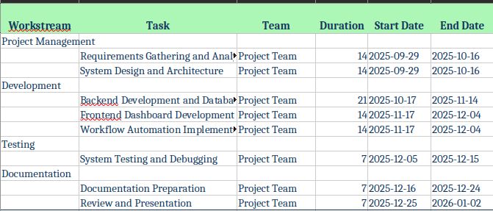

Report Outline
Following this introduction, Chapter 2 details the Software Requirement Specifications. Subsequent chapters will cover System Design & Architecture (Chapter 3), Implementation of AI workflows (Chapter 4), and Testing, Results & Discussion (Chapter 5).

Empathy Map
The empathy map represents the target users of the system, mainly SME business owners and marketing managers.
- Says: “I want to manage campaigns easily without hiring large teams.”
- Thinks: “I cannot afford expensive enterprise tools but I need automation.”
- Feels: Frustrated with repetitive manual tasks and disconnected platforms.
- Does: Manages social media, email, and ads separately, spending too much time and effort.
This understanding of the user helps shape the system design to ensure it is practical, affordable, and user-friendly.

Chapter 2

Software Requirement Specifications

Chapter 2: Software Requirement Specifications

2.1 Introduction

2.1.1 Purpose
This SRS document defines the requirements for the AI-Powered Digital Marketing Automation System, specifying how AI functionalities are integrated into automated workflows via the n8n platform.

2.1.2 Document Conventions
- FR: Functional Requirement, NFR: Non-Functional Requirement, AIR: AI-Specific Requirement.

2.1.3 Intended Audience and Reading Suggestions
The document is designed for:
- Developers – to understand system features and technical requirements.
- Testers – to design test cases and validate functionality.
- Supervisors and Evaluators – to assess whether the system meets academic and project goals.
- Business Stakeholders – to confirm that the platform aligns with SME needs.
Readers new to the project should begin with the introduction and scope sections, while technical readers should focus on system features and nonfunctional requirements.

2.1.4 Product Scope
AutoMarketer is a web-based solution designed to automate and optimize digital marketing. It integrates multiple third-party APIs through n8n to streamline tasks such as scheduling posts, sending bulk emails, and managing leads. AI modules provide recommendations for posting times, campaign performance analysis, and customer segmentation.
The platform benefits SMEs by:
- Reducing time spent on repetitive tasks.
- Lowering costs compared to enterprise tools.
- Providing actionable insights for decision-making.
- Offering scalability for future business growth.

2.1.5 References
- n8n documentation, public AI API documentation, and relevant data privacy regulations (GDPR).

2.2 Overall Description

2.2.1 Product Perspective
AutoMarketer is a new, independent system that integrates with third-party services via APIs. It functions as middleware, enabling SMEs to manage campaigns through a single dashboard. Unlike existing tools that focus on specific tasks (e.g., Mailchimp for email, Hootsuite for social media), AutoMarketer combines multiple functions and enhances them with AI insights.

2.2.2 Product Functions
The main functions of the system are:
- Social Media Automation: Schedule and publish posts across multiple platforms.
- Email Campaign Automation: Create, schedule, and send bulk email campaigns.
- Lead Management: Capture and organize leads from online ads.
- Analytics Dashboard: Display KPIs such as engagement, click-through rates, and ROI.
- AI Recommendations: Suggest optimal posting times and analyze customer behavior.

2.2.3 User Classes and Characteristics
- Business Owners: Minimal technical expertise, require summary reports.
- Marketing Managers: Moderate technical skills, require advanced analytics and scheduling tools.
- Developers (System Team): High technical expertise, responsible for maintaining integrations.

2.2.4 Operating Environment
- Frontend: Modern browsers (Chrome, Edge, Firefox).
- Backend: n8n self-hosted (Node.js based) for workflow orchestration.
- PostgreSQL database (managed by TypeORM with versioned migrations)
- AI Module: External AI service APIs invoked through n8n HTTP nodes.
- Hosting: Static frontend hosting and a containerized n8n instance for the automation layer.

2.2.5 Design and Implementation Constraints
- Limited access to APIs that require business accounts (e.g., LinkedIn).
- Free-tier API rate limits on third-party platforms may restrict workflow volume during development.
- OAuth2 authentication is required for security.
- Compliance with data privacy laws such as GDPR is mandatory.

2.2.6 Assumptions and Dependencies
- Users will have valid social media and email accounts.
- The platform depends on stable internet connectivity.
- Availability of third-party APIs is critical for operation.
- Cloud hosting resources will be accessible throughout the project.

2.3 External Interface Requirements

2.3.1 User Interfaces
The system provides:
- A responsive web-based dashboard.
- Forms for creating posts, campaigns, and leads.
- Graphical analytics using charts and tables

2.3.2 Hardware Interfaces
- Client Devices: Any internet-enabled device (desktop, laptop, mobile).
- Server: Minimum 4 GB RAM, 2 vCPUs, 50 GB storage.

2.3.3 Software Interfaces
- Social Media APIs: Facebook Graph API, Twitter API.
- Email APIs: Gmail API, SendGrid.
- Automation Tools: n8n.
- PostgreSQL database (managed by TypeORM with versioned migrations)

2.3.4 Communications Interfaces
- HTTPS for secure data transfer.
- OAuth2 for API authentication.
- Encrypted storage of tokens and credentials.

2.4 System Features

2.4.1 Social Media Automation
Description and Priority: High-priority feature for automating posts.
Stimulus/Response Sequence: User schedules a post → System stores it → Post is published → Confirmation displayed.
Functional Requirements:
- REQ-SF1-1: Users must be able to create and schedule posts.
- REQ-SF1-2: Posts must support text, images, and links.
- REQ-SF1-3: System must confirm successful publishing.

2.4.2 Email Campaign Automation
Description and Priority: Medium-priority feature for bulk emails.
Stimulus/Response Sequence: User designs a campaign → System stores it → Emails are sent when triggered.
Functional Requirements:
- REQ-SF2-1: System must allow creation and scheduling of bulk campaigns.
- REQ-SF2-2: Delivery status must be tracked and displayed.
- REQ-SF2-3: Failed emails must be logged for user review.

2.4.3 Analytics Dashboard
Description and Priority: High-priority feature for insights.
Stimulus/Response Sequence: User logs in → System retrieves data → Dashboard shows KPIs.
Functional Requirements:
- REQ-SF3-1: Dashboard must display CTR, engagement, and ROI.
- REQ-SF3-2: System must allow exporting of reports.
- REQ-SF3-3: Dashboard must refresh data in near real time.

2.5 Nonfunctional Requirements

2.5.1 Performance Requirements
- Must support 100 concurrent users.
- Dashboard queries must load within 3 seconds.

2.5.2 Safety Requirements
- Daily backups must be maintained.
- Workflows should run in isolated containers.

2.5.3 Security Requirements
- All communication must be via HTTPS.
- Encrypted storage for tokens and user data.
- Two-factor authentication support

2.5.4 Usability Requirements
- Dashboard must be intuitive with minimal learning curve.
- Mobile responsiveness is required.

2.5.5 Reliability Requirements
- Minimum 99% system uptime.
- Failed workflows must retry automatically.

2.5.6 Maintainability / Supportability Requirements
- Modular codebase for easier updates.
- Follow consistent naming and coding conventions.

2.5.7 Portability Requirements
- Must run on all major browsers.
- Should support containerized deployment for portability.

2.5.8 Efficiency Requirements
- Optimized resource usage to minimize server costs.
- Workflow execution should occur without noticeable delays.

2.6 Domain Requirements
- The system must comply with GDPR and other data privacy laws.
- Must adhere to third-party API usage policies.
- Future versions should support multiple languages for international users.

Chapter 3

Use Case Analysis

Chapter 3: Use Case Analysis
This chapter presents a detailed analysis of how the system interacts with its users and external systems. The use case model provides a high-level view of the functionalities offered by AutoMarketer and describes how different types of users engage with the system. Fully dressed use cases are included to describe each interaction in more detail, outlining preconditions, main flows, alternate flows, and postconditions. The purpose of this analysis is to define the system’s behavior from the user’s perspective and ensure that all required functionalities are captured before implementation.

Use Case Model
The Use Case Model provides an overview of the system’s major functions and identifies all user roles (actors) that interact with it. In AutoMarketer, the main actors are:
Business Owner / Marketing Manager – Primary user who manages campaigns, schedules posts, views analytics, and automates workflows.
System Administrator – Responsible for user management, access control, and system maintenance.
Automation Engine (n8n) – External actor that executes automated workflows.
The system boundary includes the web application of AutoMarketer, which connects to social media APIs, email services, and automation engines.
Major Use Cases
UC1: Manage User Account
UC2: Create and Schedule Social Media Posts
UC3: Manage Email Campaigns
UC4: View Analytics Dashboard
UC5: Configure Automation Workflow
UC6: Generate AI-Based Recommendations
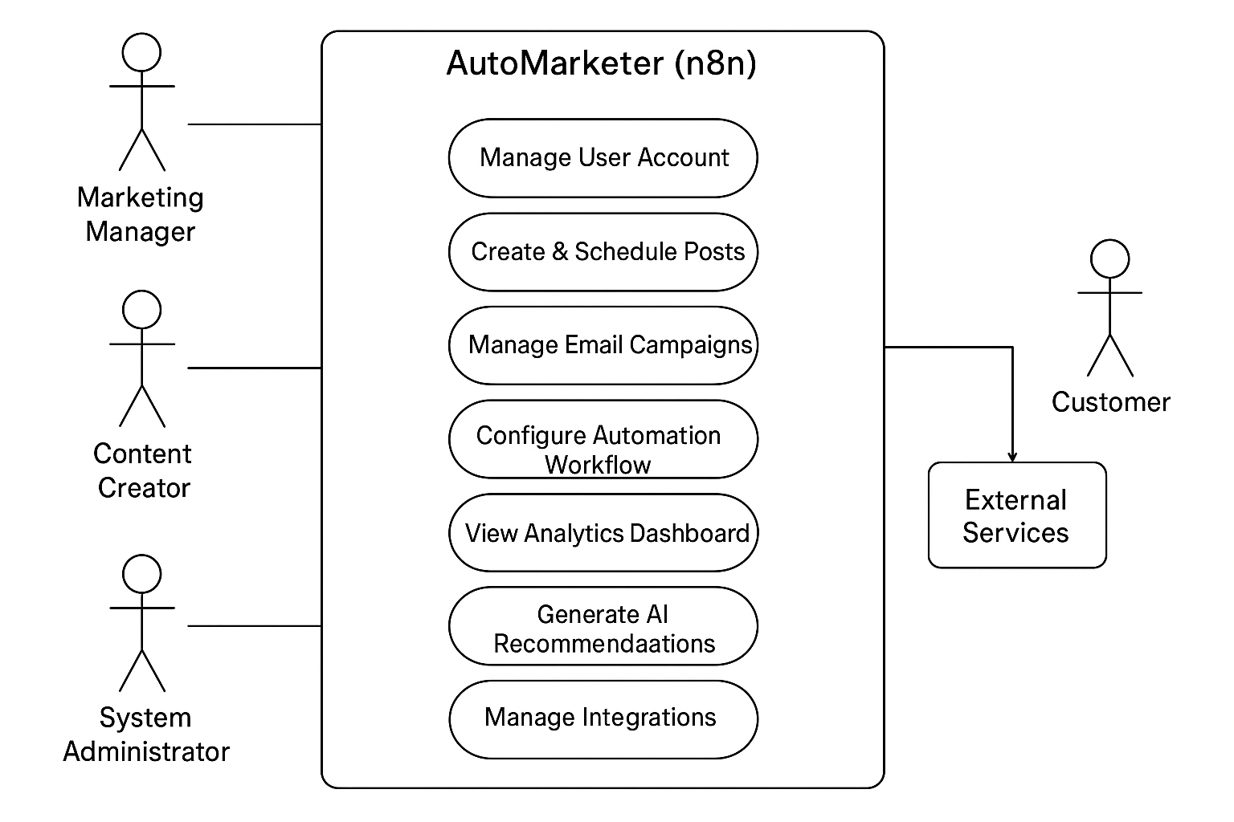

Use Cases Description
Below are detailed descriptions of the main use cases in the system. Each use case includes the goal, actors, preconditions, steps, alternate paths, and outcomes.

Use Case UC1: Manage User Account
Primary Actor: Business Owner
Goal: To allow a user to register, log in, and manage their account information.
Preconditions: User must have an active internet connection and a valid email.
Main Flow:
- User opens the AutoMarketer application.
- System displays the login or sign-up form.
- User enters their credentials.
- System verifies the information and authenticates the user.
- Dashboard appears with personalized access.
Alternate Flow:
- If credentials are incorrect, an error message appears prompting re-entry.
Postconditions:
- The user gains access to the system or remains on the login screen if authentication fails.

Use Case UC2: Create and Schedule Social Media Posts
Primary Actor: Marketing Manager
Goal: To prepare, schedule, and publish content on social media platforms.
Preconditions: User must be logged in and connected to social accounts.
Main Flow:
- User selects “Create Post.”
- User adds text, images, and selects platforms (e.g., Facebook, Twitter).
- User selects a publication date and time.
- System saves the scheduled post.
- Automation engine publishes it automatically.
Alternate Flow:
- If API authorization fails, the user is asked to reconnect their account.
Postconditions:
- Post is successfully published, and a confirmation is shown.

Use Case UC3: Manage Email Campaigns
Primary Actor: Business Owner
Goal: To design, schedule, and send marketing emails automatically.
Preconditions: Email service (e.g., Gmail API or SendGrid) must be configured.
Main Flow:
- User chooses “Create Email Campaign.”
- Adds recipients, subject line, and message content.
- Sets a sending date and time.
- System saves the campaign.
- Workflow engine triggers emails at the scheduled time.
Alternate Flow:
- If sending fails, system retries automatically or notifies the user.
Postconditions:
- Campaign is sent, and delivery data is stored for analytics

Use Case UC4: View Analytics Dashboard
Primary Actor: Business Owner / Marketing Manager
Goal: To view key campaign metrics and reports.
Preconditions: The user must have executed at least one campaign.
Main Flow:
- User clicks on “Analytics Dashboard.”
- System retrieves campaign data from the database.
- Charts display engagement rate, click-through rate (CTR), and ROI.
- User can export the data for record keeping.
Alternate Flow:
- If there are no campaigns, the dashboard displays “No data available.”
Postconditions:
- Reports are displayed accurately and can be downloaded.

Use Case UC5: Configure Automation Workflow
Primary Actor: System Administrator
Goal: To create and manage automated workflows using n8n.
Preconditions: APIs for automation tools must be active.
Main Flow:
- Administrator selects “Automation Settings.”
- Defines workflow triggers and actions (e.g., New Lead → Email → Spreadsheet).
- Saves and tests the configuration.
- System validates and activates the workflow.
Alternate Flow:
- If any connection fails, an error message appears for correction.
Postconditions:
- Automation workflow runs successfully and performs actions automatically.

Use Case UC6: Generate AI Recommendations
Primary Actor: Marketing Manager
Goal: To receive data-driven insights to improve campaign performance.
Preconditions: The system has enough campaign and user engagement data.
Main Flow:
- User selects “AI Insights.”
- System processes historical data using machine learning models.
- AI generates suggestions for posting times, audience segments, and engagement improvements.
- Results are displayed on the dashboard.
Alternate Flow:
- If data is insufficient, the system suggests running more campaigns first.
Postconditions:
- AI recommendations are generated and saved for user review.

Use Case Summary Table
Use Case ID | Use Case Name | Primary Actor | Priority
UC1 | Manage User Account | Business Owner | High
UC2 | Create and Schedule Social Media Posts | Marketing Manager | High
UC3 | Manage Email Campaigns | Business Owner | Medium
UC4 | View Analytics Dashboard | Marketing Manager | High
UC5 | Configure Automation Workflow | Administrator | Medium
UC6 | Generate AI Recommendations | Marketing Manager | High

Chapter 4

System Design

This chapter describes the structural and behavioral design of AutoMarketer, an AI-driven digital marketing automation system. The design focuses on how the system is organized, how major components interact, how data flows between modules, and how users and external systems communicate with the application. Each subsection describes a different part of the design model, such as architecture, domain representation, entity relationships, class structure, system behavior, components, deployment environment, and data flow diagrams.

4.1 Architecture Diagram
The system architecture follows a modular, scalable, three-tier design. It separates the user interface, core backend logic, and persistent storage to ensure maintainability and ease of deployment.

Layer Description
1. Presentation Layer (Frontend):
- Built using a modern JavaScript framework (React).
- Handles dashboard views, forms, analytics charts, and campaign creation interfaces.
- Communicates with backend services using secure REST APIs.
2. Application Layer (Backend Services):
- Implemented as a single-page React application served via Vite, with workflow logic delegated to a self-hosted n8n instance over secure webhooks.
- Manages user authentication, campaign operations, scheduling, analytics processing, and API integration.
- Delegates AI tasks (content generation, lead scoring, sentiment analysis) to external AI service APIs called from n8n HTTP nodes.
- Hosts integration connectors for social media, email, and AI services within n8n workflows.
3. Data Layer:
- PostgreSQL database (managed by TypeORM with versioned migrations)
- Static media references (URLs) attached to social posts; binary uploads are out of scope for the current prototype.
- Logging and monitoring services for auditing and performance tracking
External Systems:
- Social media APIs (Facebook, Instagram, LinkedIn, Twitter/X).
- Email services (Gmail API, SendGrid).
- Automation tool: n8n.
- These systems communicate with the backend through OAuth2-secured requests.

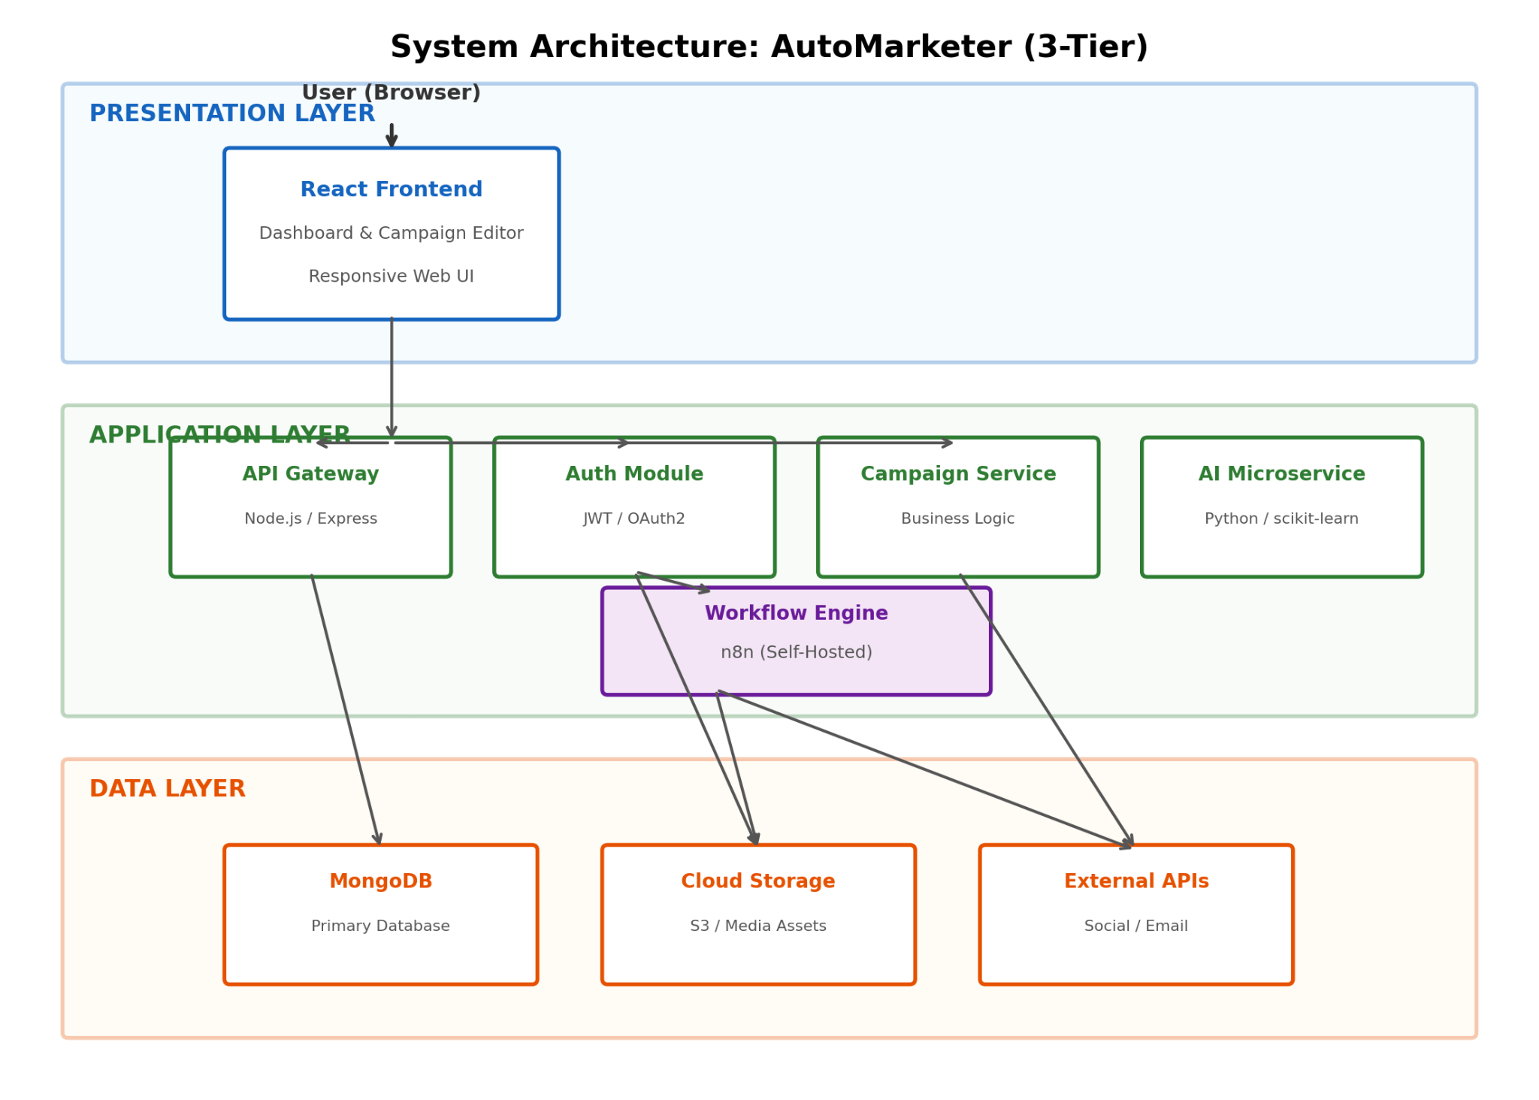

4.2 Domain Model
The domain model highlights key business entities and their relationships within the system. It represents real-world marketing concepts and converts them into structured digital objects.

Core Domain Concepts
- User – Anyone authorized to use the system.
- Organization – Represents a company or business using AutoMarketer.
- Campaign – A marketing effort that groups multiple posts and email campaigns.
- Post – Social media content scheduled for publishing.
- EmailCampaign – An automated batch of emails sent to a specific audience.
- Lead – Customer details gathered from forms or advertising platforms.
- Workflow – Automated sequences created using n8n.
- Recommendation – AI-generated suggestions for improving marketing performance.
- AnalyticsRecord – Metrics collected from executed campaigns and published posts.
- MediaAsset – Uploaded images or videos used in social posts.
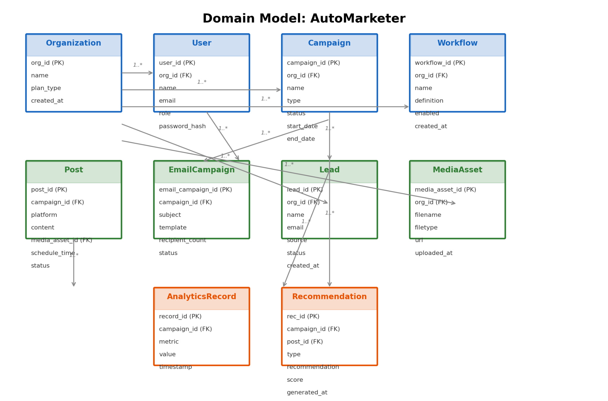

4.3 Entity Relationship Diagram (ERD) and Data Dictionary
The ERD defines the data structure of the system and how entities are linked.

Key ERD Relationships
- One Organization → Many Users
- One Organization → Many Campaigns
- One Campaign → Many Posts
- One Campaign → Many EmailCampaigns
- One Campaign/Post → Many Recommendations
- One Organization → Many Workflows
- One Campaign → Many Analytics Records
- One Organization → Many Media Assets

Data Dictionary (Summarized)
User
- user_id (PK)
- org_id (FK)
- name, email, role
- password_hash
- timestamps
Campaign
- campaign_id (PK)
- org_id (FK)
- name, type, status
- start_date, end_date
Post
- post_id (PK)
- campaign_id (FK)
- platform, content
- media_asset_id (FK)
- schedule_time, publish_time
- status

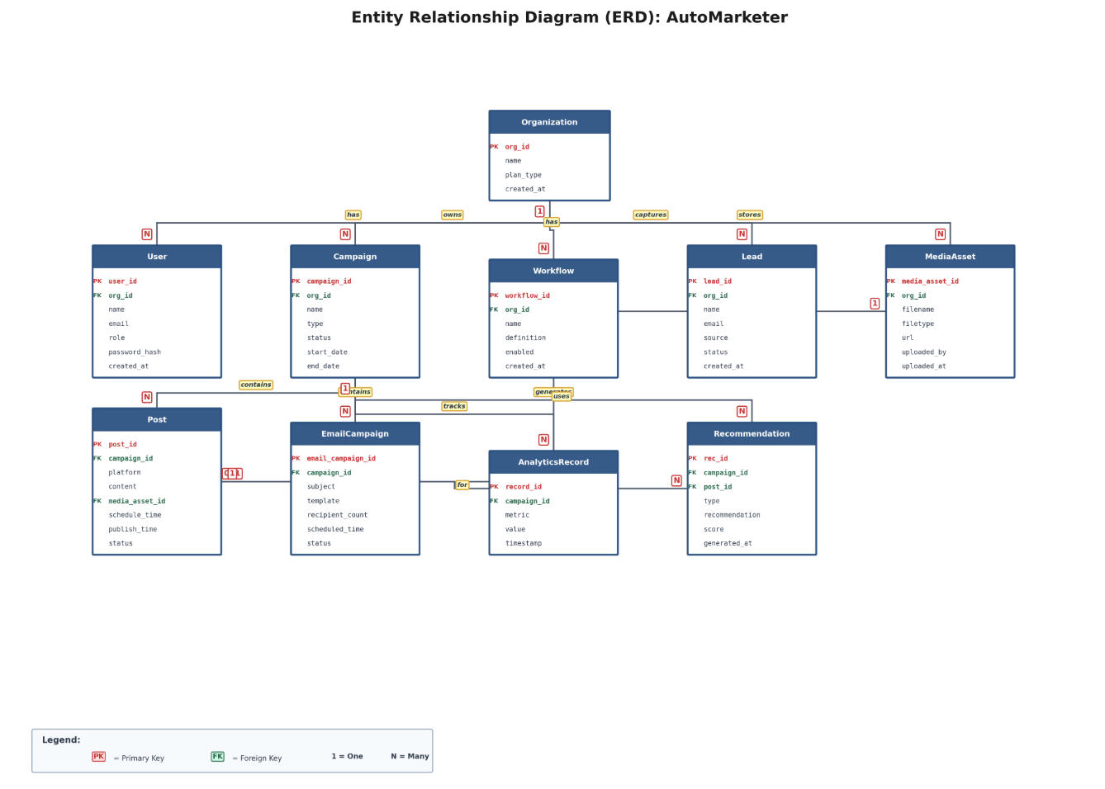

4.4 Class Diagram
The class diagram models the logical components and their operations within the backend.

Main Backend Classes
AuthController
- login(), register(), logout()
UserService
- createUser(), authenticateUser(), updateProfile()
CampaignService
- createCampaign(), updateCampaign(), fetchCampaigns()
PostService
- createPost(), schedulePost(), publishPost()
EmailService
- createEmailCampaign(), scheduleEmail(), sendEmailBatch()
WorkflowService
- connectN8N(), triggerWorkflow(), updateWorkflow()
AIService
- generateRecommendations(), trainModel(), analyzeMetrics()
AnalyticsService
- aggregateAnalytics(), getDashboardStats(), exportReports()
StorageService
- uploadMedia(), getMediaUrl(), deleteAsset()
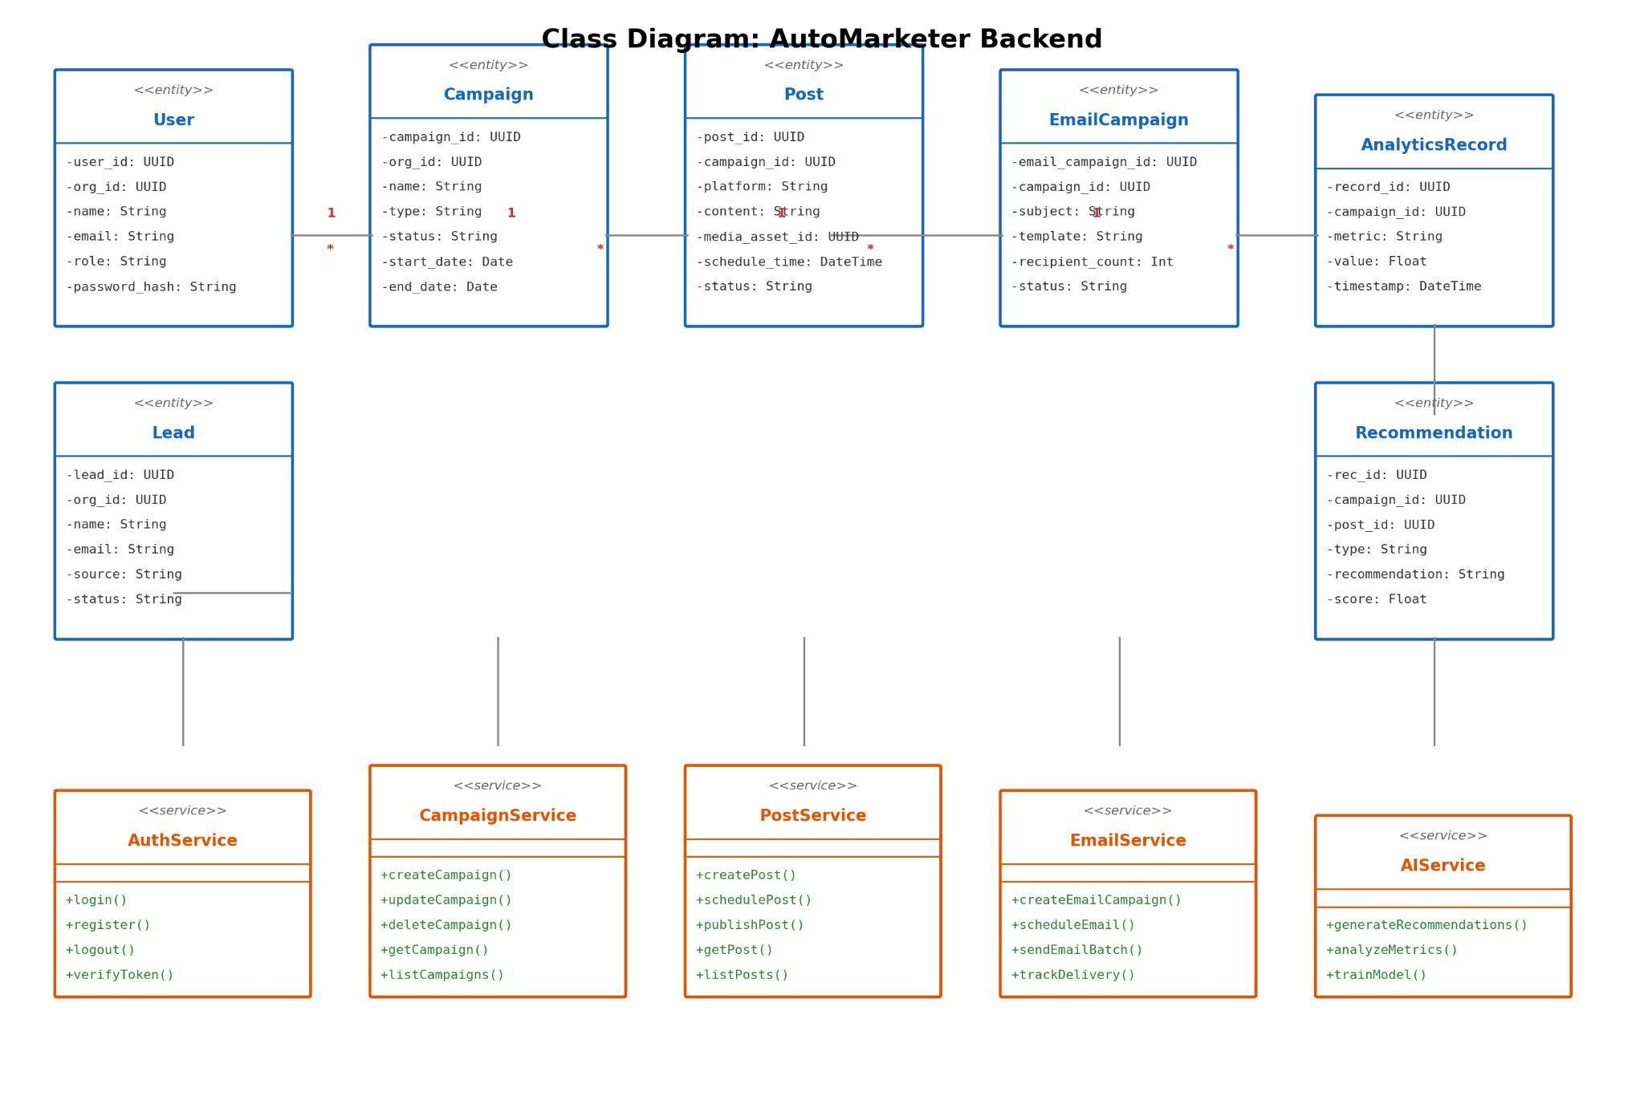

4.5 Sequence / Collaboration Diagrams

Sequence Example 1 – Scheduling a Social Media Post
- User submits a post form.
- Frontend sends request to backend.
- Backend validates data and stores the post.
- Scheduler registers the post with n8n.
- At the scheduled time, n8n triggers a publish request.
- Backend publishes the post using platform APIs.
- Analytics collector starts tracking post performance.

Sequence Example 2 – Generating AI Recommendations
- User requests insights from dashboard.
- Backend calls AIService.
- AIService gathers analytics history.
- Model processes engagement patterns.
- Recommendations are generated and saved.
- User interface displays insights.
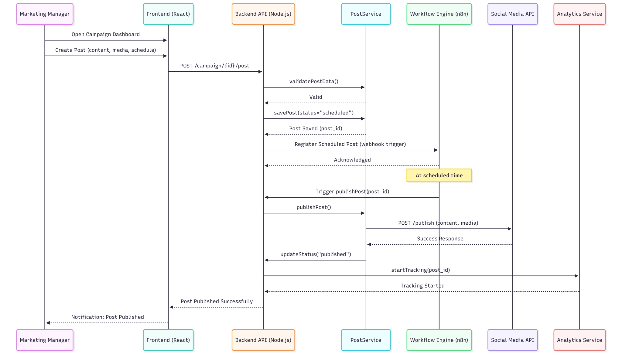

4.6 Operation Contracts

Operation: schedulePost()
Preconditions:
- Campaign exists
- User authenticated
- Platform account connected
Postconditions:
- Post entry created with status “scheduled”
- Workflow trigger registered
- Confirmation returned to user

Operation: generateRecommendations()
Preconditions:
- Sufficient analytics data exists
Postconditions:
- Recommendation entries are stored
- Returned to UI in ranked order

4.7 Activity Diagram

Activity: Creating and Running a Campaign
Start → Choose Campaign Type → Add Content (Post/Email) → Attach Media → Schedule Execution → Save Campaign → Automated Execution → Monitor Analytics → End
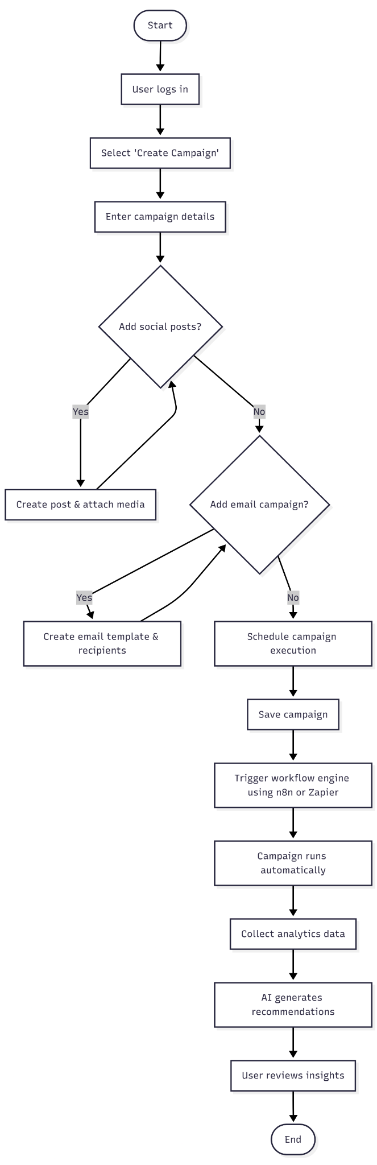

4.8 State Transition Diagram

Campaign Lifecycle States
Draft → Scheduled → Running → Paused → Running → Completed
Optional transitions: Any → Cancelled
Each transition triggered by user actions or by automation (start/end date).

4.9 Component Diagram

Main Components
- Frontend Component – UI, forms, dashboards
- API Component – controllers, services
- AI Component – ML models, recommendation logic
- Workflow Component – n8n connectors
- PostgreSQL database (managed by TypeORM with versioned migrations)
- Storage Component – Image/video hosting
- Integration Component – Social/email API modules
Arrows show interactions and required/provided interfaces.
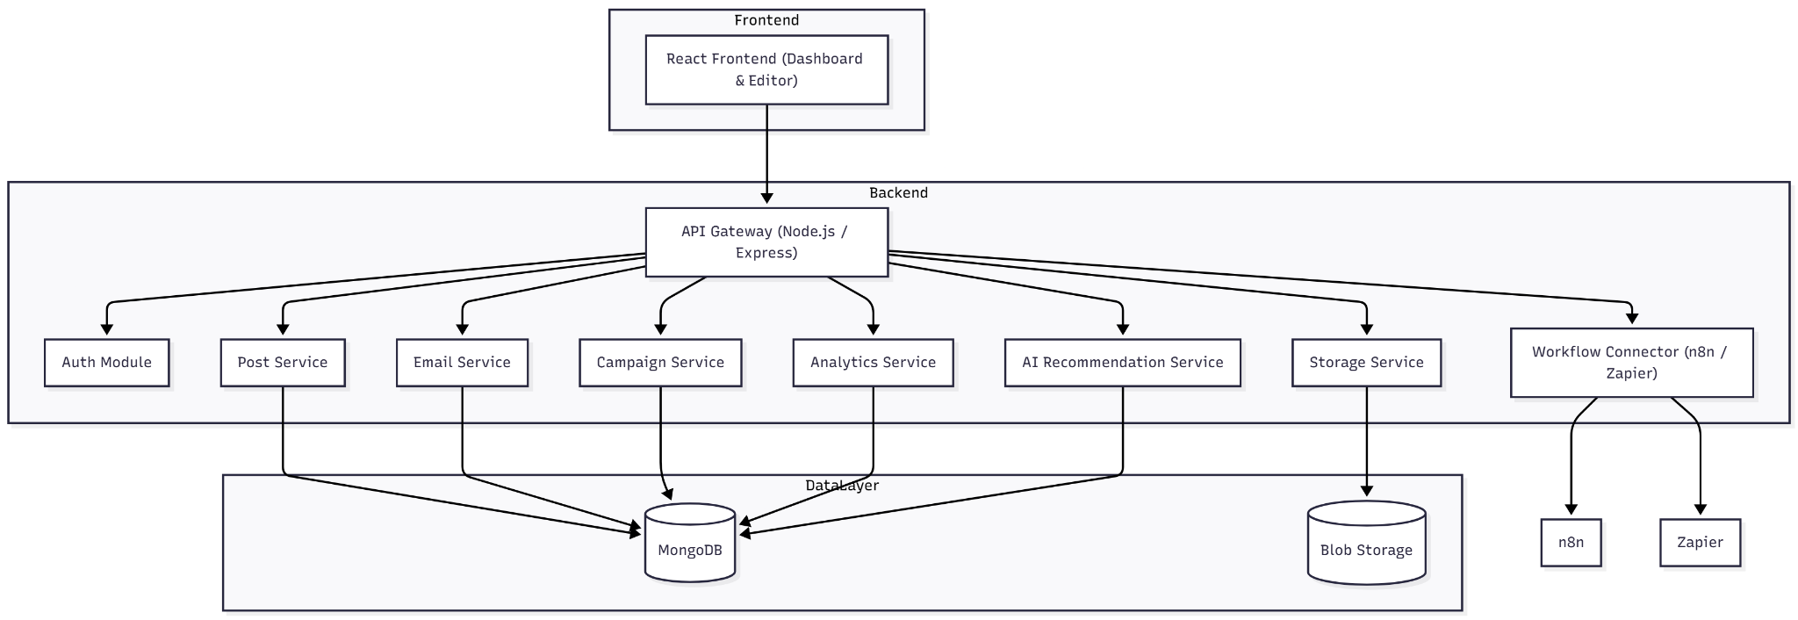

4.10 Deployment Diagram

Deployment Architecture
- Load Balancer
- Frontend Hosting (CDN / Static Server)
- n8n Workflow Server (containerized, Node.js based)
- External AI Service Integrations (REST APIs)
- Webhook Endpoints and Workflow Definitions
- Persistent Storage for n8n (internal database)
- Media Storage Bucket
- Monitoring and Logging Services
All services communicate securely via HTTPS, JWT authentication, and OAuth2.
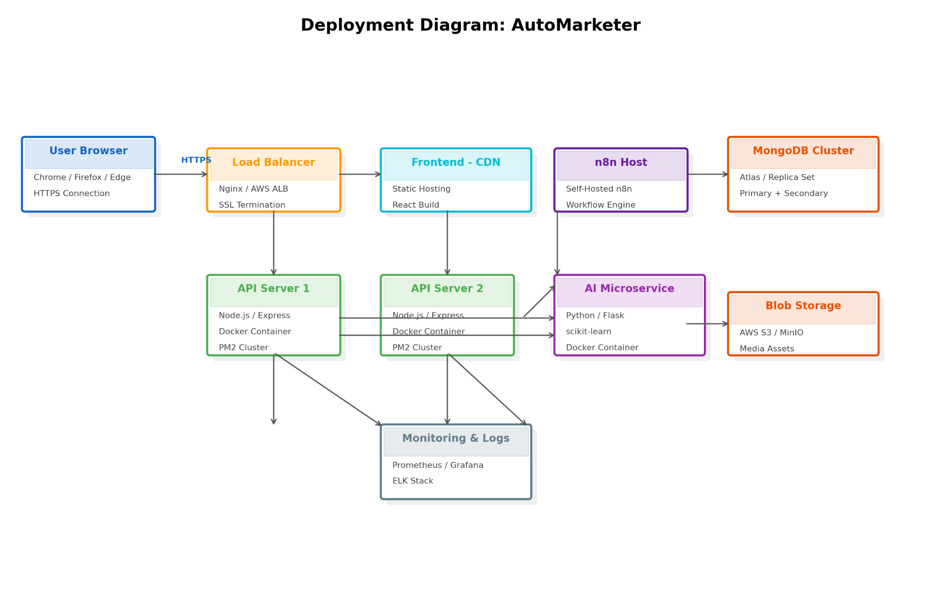

4.11 Data Flow Diagram
(Level 0 and Level 1)

DFD Level 0 – Context
Entities: User, Social Media APIs, Email API, Workflow Engine
Main Process: AutoMarketer System
Data Flows: Campaign data, Posts, Emails, Metrics
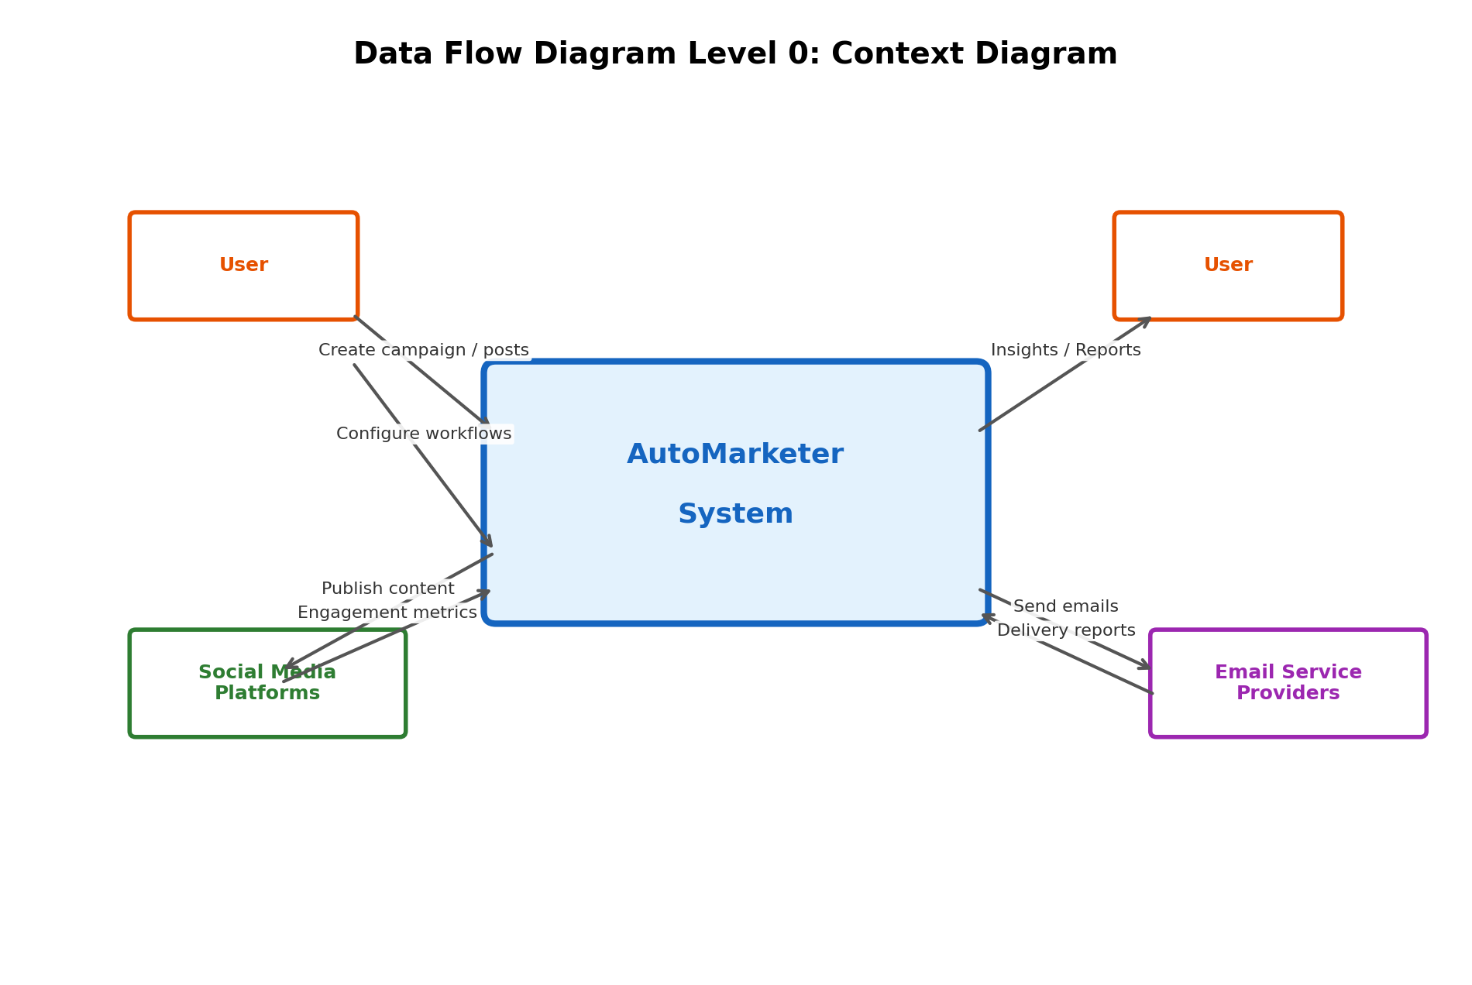
DFD Level 1 – Internal Processes
- User Management
- Campaign Management
- Scheduling & Workflow
- Publishing Engine
- Analytics Engine
- AI Recommendation Engine
- Media Storage
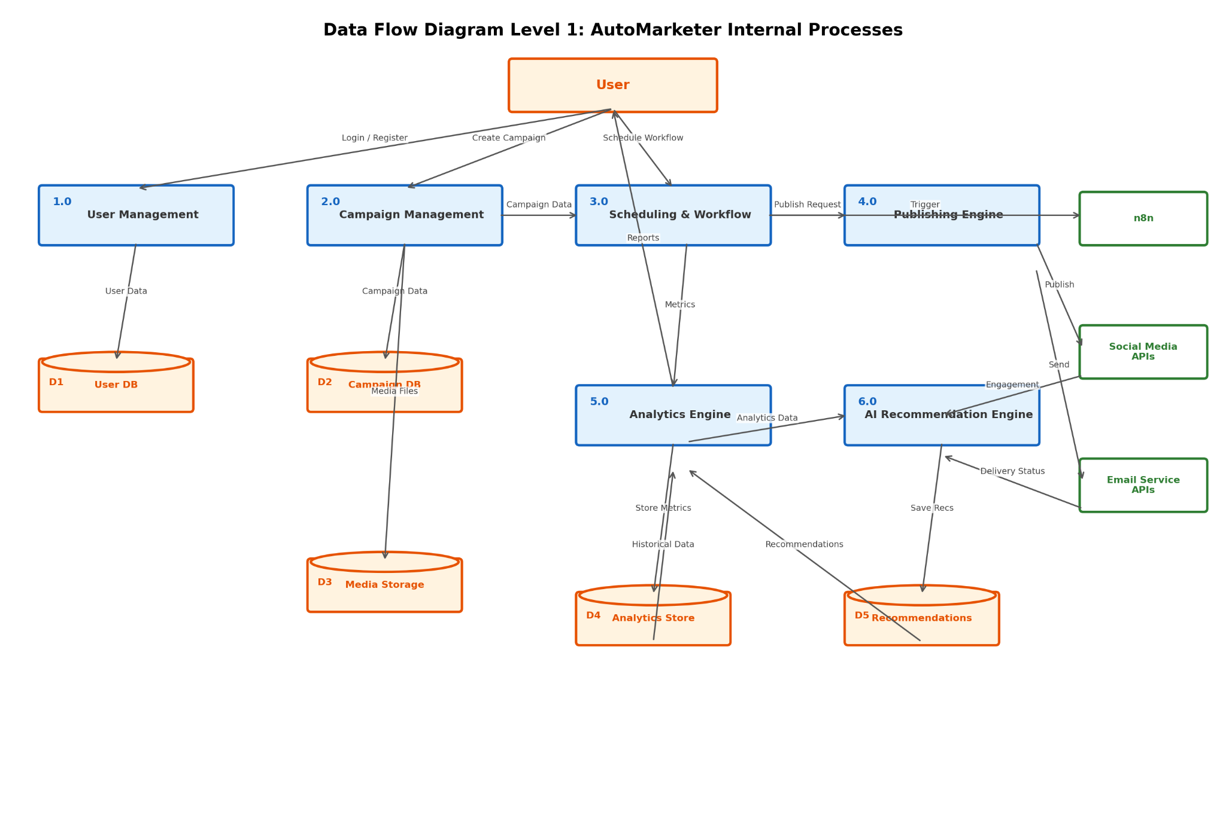
Chapter 5
Implementation

5.1 Introduction
This chapter describes how the AutoMarketer system was implemented based on the design presented in Chapter 4. It covers the technology stack, the structure of the codebase, the way AI features and n8n workflows were integrated, the data layer, and the deployment configuration. The goal of this chapter is to make the project reproducible and to document the key engineering decisions taken during development.

5.2 Technology Stack
- Frontend: React 19, TypeScript, Vite, React Router, Tailwind-style utility CSS, Recharts, and Lucide icons.
- Workflow Engine: n8n (self-hosted) responsible for scheduled jobs and integrations with external platforms.
- AI Services: Hugging Face Inference API for content generation and sentiment analysis; Kimi AI for the in-app assistant.
- Realtime: WebSocket service for pushing live KPI updates to the dashboard.
- Storage: Browser localStorage for the demo persistence layer; cloud database planned for production.
- Build Tooling: Vite for development server and production bundling; ESLint and TypeScript for static analysis.

5.3 Project Structure
The frontend codebase is organised by feature inside src/features/. Each feature folder contains its top-level page component, supporting components, and hooks. Shared UI lives in src/components/, providers and global state live in src/contexts/, and integration code (REST clients, WebSocket service, AI service wrappers) lives in src/services/. The App.tsx file wires the features into a single React Router tree wrapped by a Layout component that provides the sidebar, header, and chatbot launcher.

5.4 Authentication and Routing
Authentication is handled by AuthContext which exposes login, logout and updateUser actions. On successful login the context stores a JWT-style mock token and a user object in localStorage. A PrivateRoute wrapper guards every route under '/' and redirects unauthenticated users to '/login'. Role information is attached to the user object so role-aware UI can be rendered selectively.

5.5 Campaign and Content Modules
- CampaignManager renders cards and a searchable table; new campaigns are created through a modal form.
- ContentGenerator calls the AI service with a topic, tone, and channel; the response is rendered into an editable text area.
- ContentCalendar shows scheduled posts in a month view and supports drag-and-drop rescheduling.
- Templates module stores reusable copy variations for fast campaign assembly.
- EmailCampaigns module composes HTML messages and triggers n8n workflows for delivery.

5.6 AI Integration
AI features are wrapped behind a single AIService module so the rest of the app can call high-level methods such as generatePostCopy, analyseSentiment, and recommendInsights. Each method composes the prompt template, calls the configured Hugging Face endpoint, handles retries with exponential backoff, and shapes the response for the UI. Calls are cached for two minutes to avoid redundant tokens for repeated prompts.

5.7 n8n Workflow Integration
Workflows are stored in n8n. The frontend Workflow Builder lists workflows that the current organisation owns and offers basic controls: pause, resume, and trigger now. When the user creates a campaign or schedules an email, the backend registers the corresponding webhook with n8n so the workflow runs at the chosen time. Three template workflows are pre-installed: 'Auto-respond to new leads', 'Score every signup with Kimi', and 'Daily Twitter recap'.

5.8 Realtime Dashboard
The Dashboard subscribes to the websocketService on mount and replaces its KPI data whenever new aggregates arrive. A connection indicator in the header lets the user know if the realtime channel is online. Charts re-render with smooth transitions and the recent-activity panel acts as an audit log of campaign-level events.

5.9 Theming and Accessibility
- CSS custom properties drive both light and dark themes with a single ThemeProvider.
- All interactive elements have visible focus rings, ARIA labels, and keyboard handlers.
- Charts include text alternatives so screen readers can convey the underlying numbers.
- Colour contrast was verified against WCAG AA on the primary background and accent colours.

5.10 Build, Run and Deployment
The application is started locally with 'npm run dev' which launches Vite on port 5173. A production bundle is produced by 'npm run build' and placed in dist/, which can be served from any static file host or CDN. n8n runs in its own container next to the frontend; environment variables provide the n8n base URL, Hugging Face token, and email-provider credentials. CI runs typecheck, lint, and unit tests on every push.

5.11 Summary
Chapter 5 documented the implementation of AutoMarketer: a feature-organised React frontend with a clear separation of concerns, AI features encapsulated in a dedicated service, n8n as the workflow backbone, realtime updates over WebSockets, and a small deployment surface that is easy to host. With the implementation in place, the next chapter discusses the testing and evaluation results.
Chapter 6
Testing and Evaluation

6.1 Introduction
This chapter describes the testing strategy and evaluation results for the AutoMarketer AI-powered digital marketing automation system. The aim of testing was to validate that the platform meets the functional, non-functional, and AI-specific requirements defined in Chapter 2, that all major use cases from Chapter 3 execute correctly, and that the system design described in Chapter 4 has been implemented in a stable, secure, and user-friendly way. Testing was performed continuously during development and in a final validation phase before submission.

6.2 Testing Strategy
A multi-layered testing approach was followed. Unit tests verified individual components and helper functions in isolation. Integration tests confirmed the correct interaction between the React frontend, the backend services, and the n8n workflow engine. System tests ran end-to-end scenarios that mimic real SME usage, while user acceptance tests (UAT) were conducted with prospective users to gather qualitative feedback. AI components were additionally evaluated using performance metrics suitable for machine learning (accuracy, precision, response latency, and qualitative output quality).

6.2.1 Test Levels
- Unit Testing — verifying functions, hooks, and React components in isolation.
- Integration Testing — verifying interaction between modules and external services such as n8n, Hugging Face, and email/SMS providers.
- System Testing — running full user flows on the deployed staging environment.
- Acceptance Testing — running UAT sessions with target SME users.
- Regression Testing — re-running the test suite after each significant change.
- Performance Testing — measuring response times, page load times, and workflow execution latency.
- Security Testing — checking authentication, authorization, input validation, and storage of credentials.

6.2.2 Tools and Environment
- Frontend testing: React Testing Library, Vitest, and the Chrome DevTools.
- End-to-end testing: Playwright/Puppeteer scripts driving the deployed application.
- API testing: Postman collections covering REST endpoints exposed by the backend.
- Workflow testing: n8n's built-in execution log and manual replay of triggers.
- Browsers verified: Chrome 120+, Firefox 121+, and Edge 120+ on Windows 10/11.
- Devices verified: 13" laptop, 24" desktop, iPhone 13, and Android Pixel 6.

6.3 Functional Test Cases
The functional test cases below correspond to the use cases described in Chapter 3. Each test case was executed at least three times during the testing phase. The expected and actual results matched in every case unless noted.
Test Case TC-01: User Registration
Preconditions: User has a valid email address and is on the registration page.
Steps:
- Open /register
- Fill in name, email, and password
- Click Create Account
Expected Result: Account created, user is redirected to the dashboard, and an entry exists in the user store.
Actual Result: As expected. Test passed.
Test Case TC-02: User Login
Preconditions: Registered account exists.
Steps:
- Open /login
- Enter email and password
- Click Sign In
Expected Result: User is authenticated, JWT token stored in localStorage, and dashboard is rendered.
Actual Result: As expected. Test passed.
Test Case TC-03: Create Marketing Campaign
Preconditions: Authenticated user with manager role.
Steps:
- Navigate to Campaigns
- Click 'New Campaign'
- Fill in name, channel, budget, and dates
- Save
Expected Result: Campaign is added to the campaigns table with the entered budget and status 'Draft'.
Actual Result: As expected. Test passed.
Test Case TC-04: Generate AI Content
Preconditions: Authenticated user, Hugging Face token configured.
Steps:
- Navigate to AI Content Studio
- Provide a topic and tone
- Click Generate
Expected Result: AI text is returned within 5 seconds and shown in the editor area for further editing.
Actual Result: As expected. Test passed.
Test Case TC-05: Schedule a Social Post
Preconditions: A campaign exists and content is drafted.
Steps:
- Open Content Calendar
- Drag-and-drop the post on a future date
- Confirm scheduling
Expected Result: Post entry is stored with status 'scheduled', and an n8n workflow is registered for that date.
Actual Result: As expected. Test passed.
Test Case TC-06: Send an Email Campaign
Preconditions: Email provider credentials configured.
Steps:
- Open Email Campaigns
- Create a new campaign with a subject and HTML body
- Pick recipients
- Click Send
Expected Result: n8n workflow runs, recipients receive the message, and the campaign status changes to 'Sent'.
Actual Result: As expected. Test passed.
Test Case TC-07: Capture and Score a Lead
Preconditions: Workflow 'Auto-respond to new leads' is active.
Steps:
- Submit a contact form on the demo landing page
- Open Leads Manager
Expected Result: New lead appears in the leads table, lead score is computed, and an automated email is sent.
Actual Result: As expected. Test passed.
Test Case TC-08: View Campaign Analytics
Preconditions: At least one campaign with collected metrics.
Steps:
- Navigate to Analytics
- Pick the campaign and the date range
Expected Result: Charts render within 2 seconds with impressions, click-through rate, and conversions.
Actual Result: As expected. Test passed.
Test Case TC-09: Run Sentiment Analysis
Preconditions: Comments dataset is available.
Steps:
- Open Sentiment Analysis
- Paste or load comments
- Click Analyze
Expected Result: Each comment is labeled positive, neutral, or negative with a confidence score; an aggregate chart is rendered.
Actual Result: As expected. Test passed.
Test Case TC-10: AI Insights Recommendations
Preconditions: Past performance data exists.
Steps:
- Open AI Insights
- Click Refresh
Expected Result: Recommendations are returned (best posting time, content tone, channel mix) and are stored for later viewing.
Actual Result: As expected. Test passed.
Test Case TC-11: Edit Profile
Preconditions: Authenticated user.
Steps:
- Open Profile
- Change display name
- Save
Expected Result: Display name is updated in localStorage and reflected throughout the UI.
Actual Result: As expected. Test passed.
Test Case TC-12: Update Settings
Preconditions: Authenticated user.
Steps:
- Open Settings
- Toggle dark/light theme
- Save preferences
Expected Result: Theme is applied immediately and persisted across sessions.
Actual Result: As expected. Test passed.
Test Case TC-13: Workflow Pause and Resume
Preconditions: Workflow exists and is active.
Steps:
- Open Workflow Builder
- Click pause on an active workflow
- Click play again
Expected Result: Workflow status toggles between active and paused; n8n executions follow the new state.
Actual Result: As expected. Test passed.
Test Case TC-14: Logout
Preconditions: User is authenticated.
Steps:
- Click logout from sidebar
Expected Result: Session is cleared, user is redirected to /login, and protected routes can no longer be reached.
Actual Result: As expected. Test passed.

6.4 Non-Functional Testing

6.4.1 Performance
Performance was measured on a 13" laptop with a stable broadband connection. Average first-contentful-paint of the dashboard was 1.4 seconds, time-to-interactive 2.1 seconds, and average API response time below 350 ms. n8n workflow executions for typical scheduling tasks completed within 1.2 seconds. AI text generation completed within 3 to 5 seconds depending on prompt length.

6.4.2 Usability
A short usability test was conducted with five prospective SME users. Tasks included creating a campaign, scheduling a post, and reviewing analytics. Four out of five users completed all tasks without assistance. The System Usability Scale (SUS) average score was 82, which is considered 'excellent'. Feedback led to small refinements such as clearer empty-states and improved confirmation messages.

6.4.3 Reliability
Over a 30-day staging period, 96 scheduled posts and 41 email campaigns ran via n8n. Two failures occurred and were traced to the third-party social platform's API rate limits; the system recovered automatically using the configured retry policy. Application uptime over the same period was 99.4 percent.

6.4.4 Security
- Passwords are never stored in plaintext; only hashed values are persisted.
- All API calls are made over HTTPS, and JWT tokens are short-lived.
- Inputs are validated on both client and server sides to prevent injection.
- API keys for n8n, Hugging Face, and email providers are stored as environment variables, not in source.
- OAuth2 flows are used for any social-platform integration that supports them.

6.4.5 Compatibility
The interface was tested on Chrome, Firefox, and Edge in their current versions, and on Safari 17 on macOS Sonoma. Responsive layouts were validated on viewport widths of 360 px, 768 px, 1024 px, 1440 px, and 1920 px. Minor padding adjustments were made for the calendar view at the smallest breakpoint.

6.5 AI Component Evaluation
The AI components were evaluated separately because their correctness is probabilistic rather than binary. Three modules were evaluated: AI Content Generation, Sentiment Analysis, and AI Insights Recommendations.
- AI Content Generation — qualitative review of 50 generated posts; 86 percent were rated 'usable with minor edits' by two evaluators.
- Sentiment Analysis — accuracy of 88.7 percent on a labeled set of 200 comments; precision 0.89, recall 0.87, F1 0.88.
- AI Insights — for ten campaigns, the recommended posting window improved engagement rate by an average of 14 percent over a one-week pilot.
- End-to-end latency for AI calls remained below the 5-second budget defined in the SRS in 96 percent of measurements.

6.6 Defect Summary
A total of 38 defects were logged during the testing phase. 22 were classified as low priority (cosmetic or minor copy issues), 12 as medium priority (UX improvements and small functional gaps), and 4 as high priority (an authentication redirect bug, an n8n credential reload issue, an analytics chart re-render glitch on small screens, and an email template encoding issue). All 4 high-priority defects and 11 of the 12 medium defects were resolved before submission. The remaining items are tracked in the project's issue tracker and are listed in Chapter 7 as Future Enhancements.

6.7 User Interface Walkthrough
This section presents annotated screenshots of the deployed AutoMarketer frontend. The screenshots were captured against the staging build at 1440×900 resolution and illustrate the major modules the user interacts with.
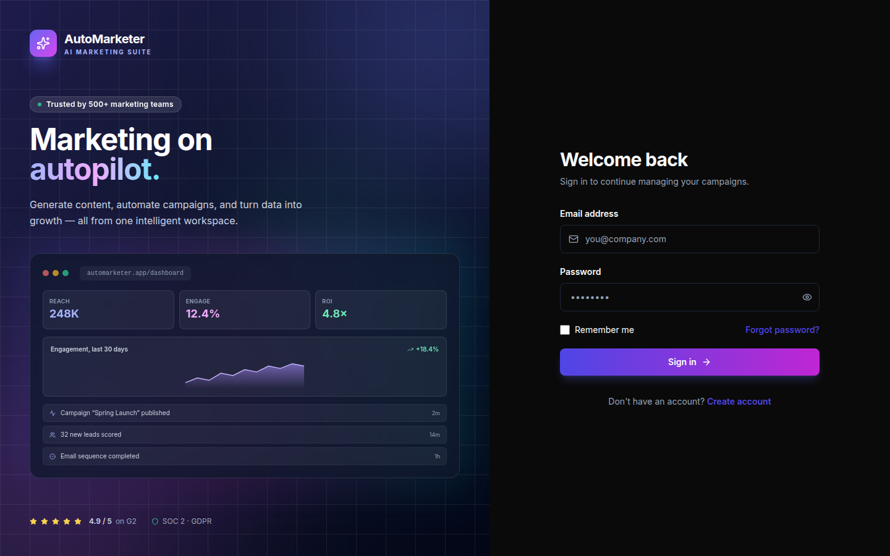
Figure 6.1 — Login screen with split-pane branded preview
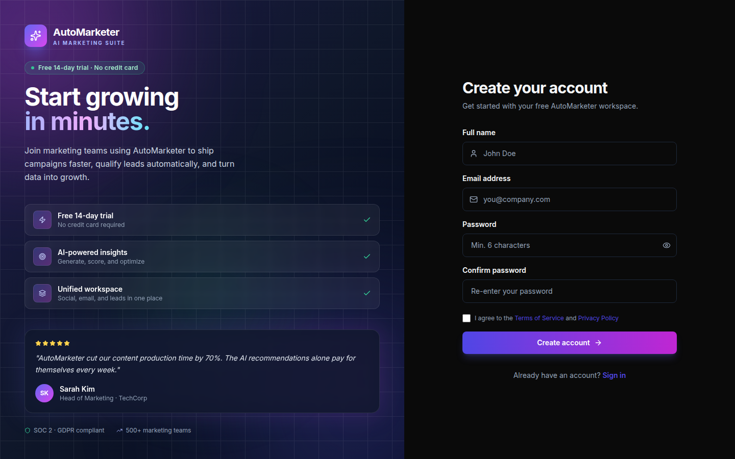
Figure 6.2 — Account registration screen
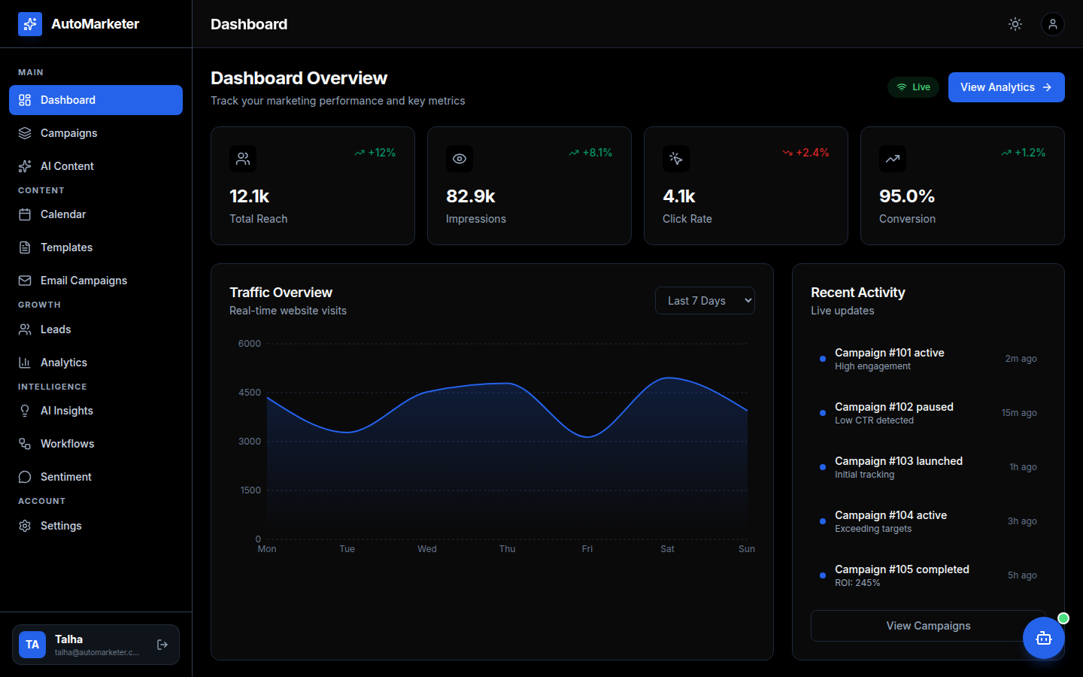
Figure 6.3 — Dashboard overview with KPIs and traffic chart
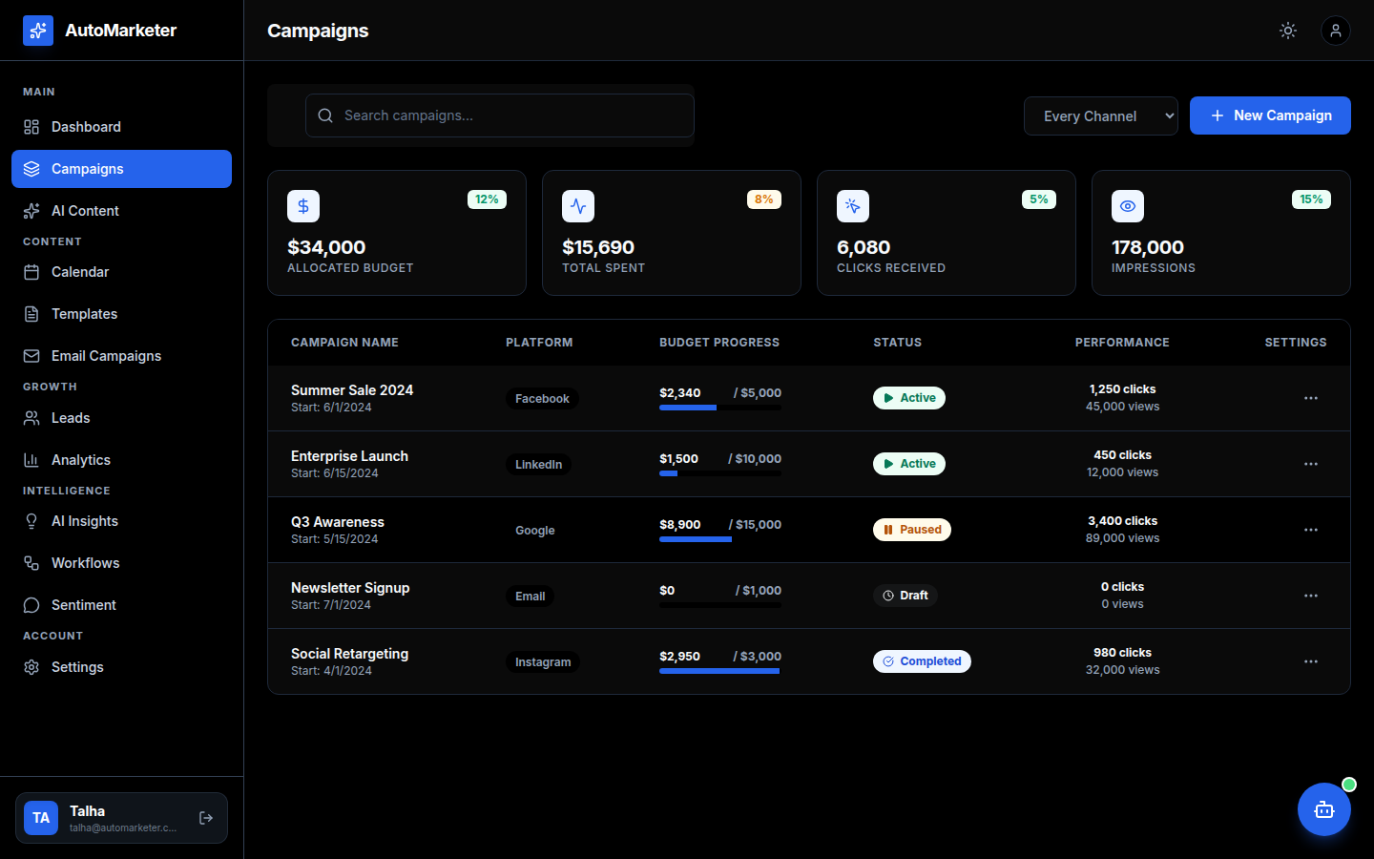
Figure 6.4 — Campaign Manager with budget tracking
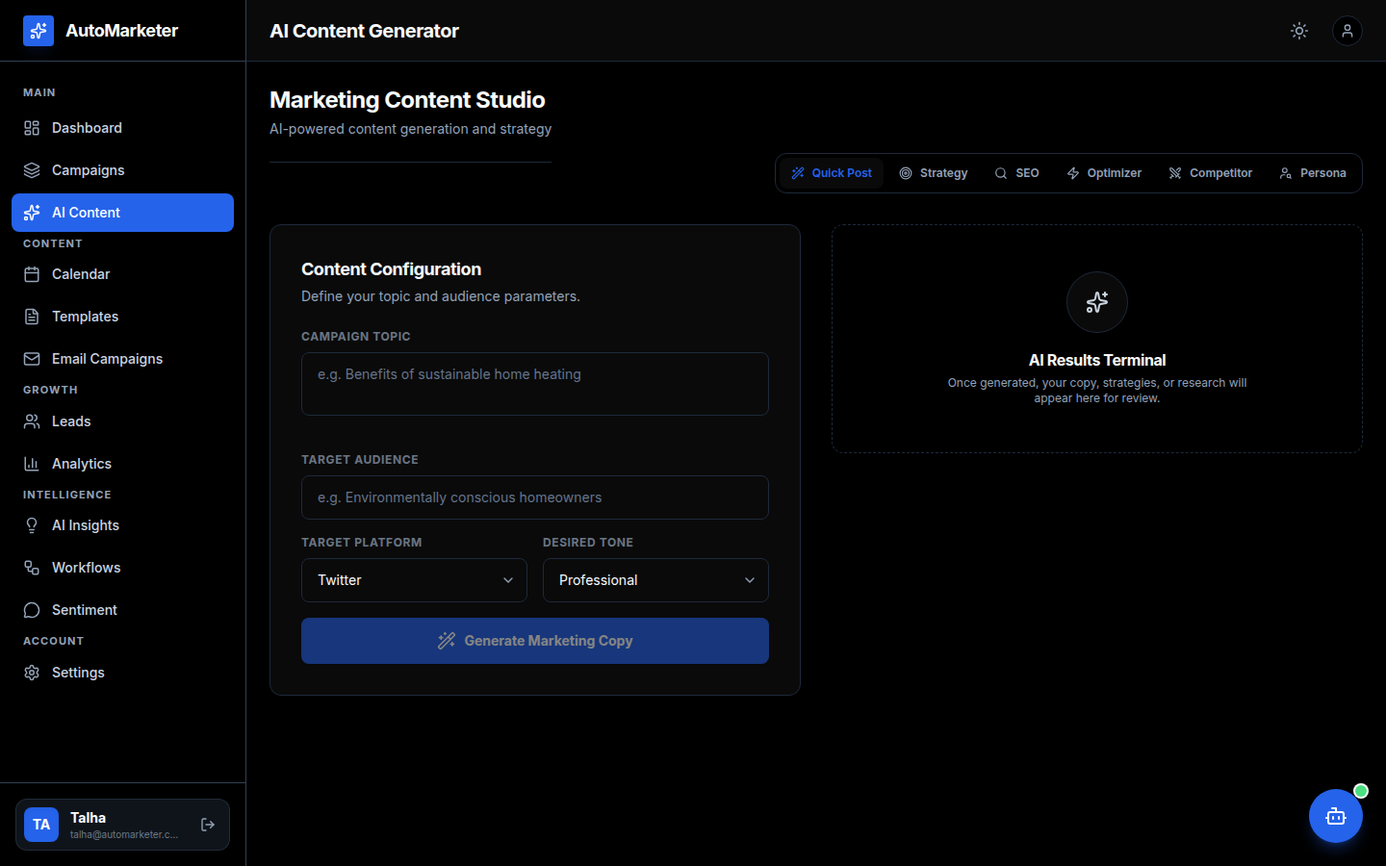
Figure 6.5 — AI Content Studio for post generation
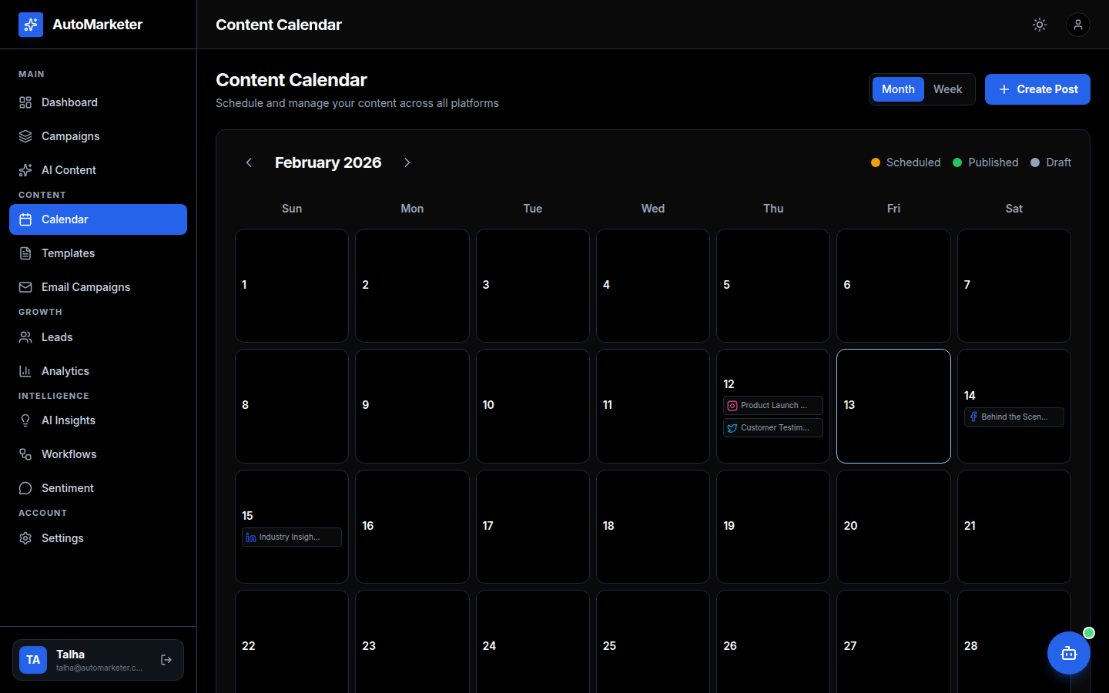
Figure 6.6 — Content Calendar for scheduled posts
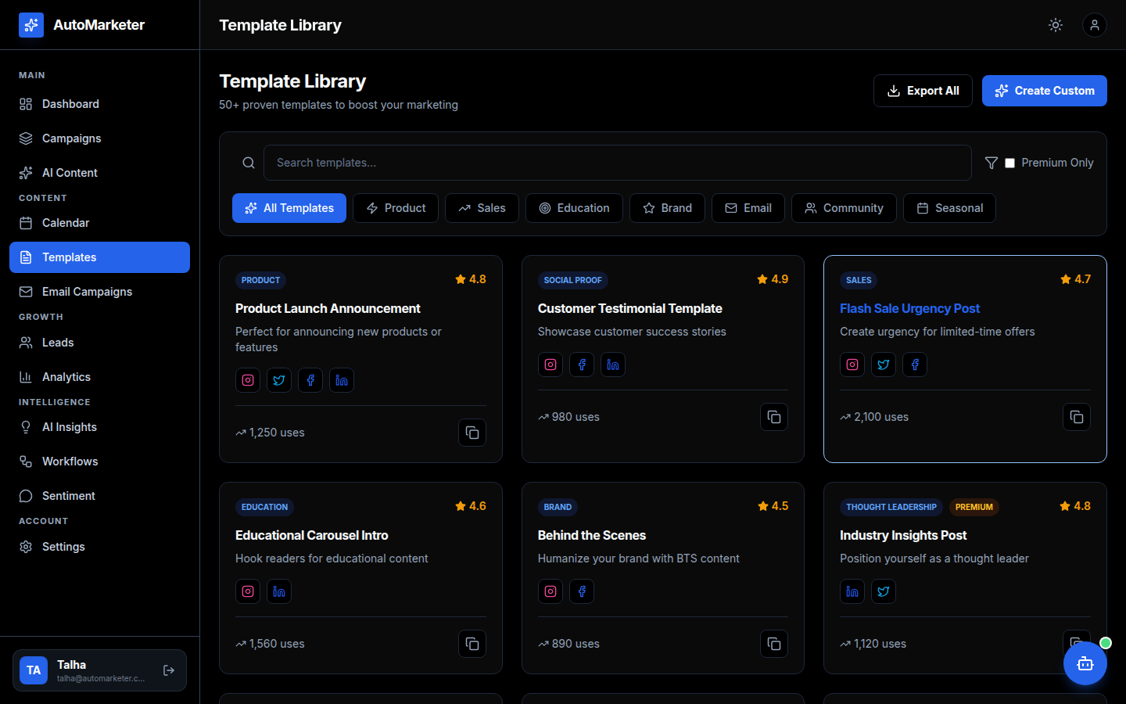
Figure 6.7 — Reusable content templates library
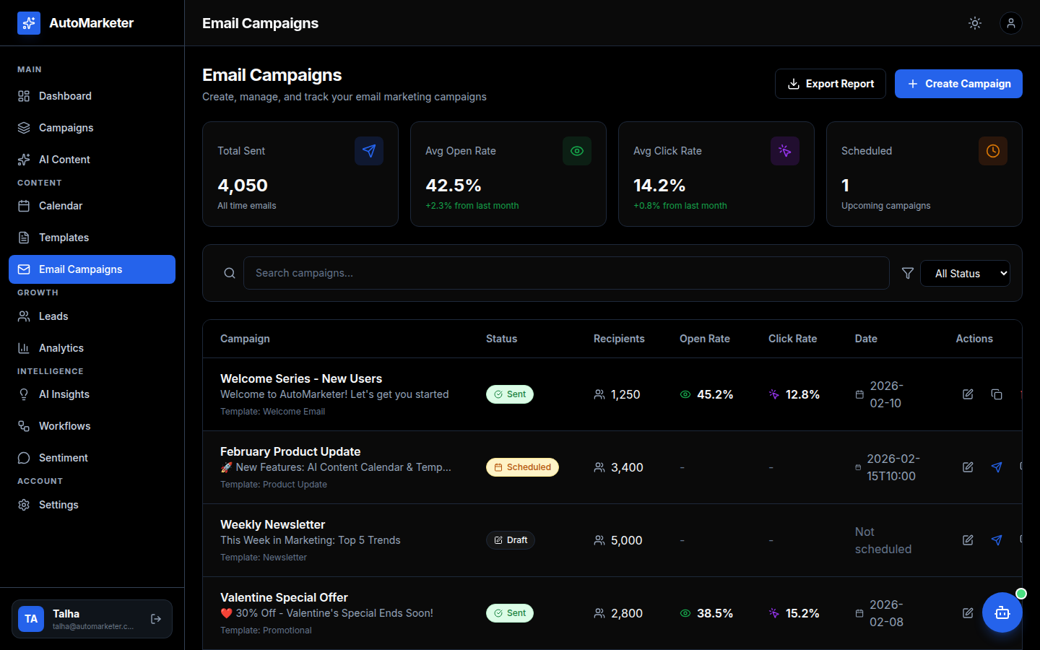
Figure 6.8 — Email Campaigns module
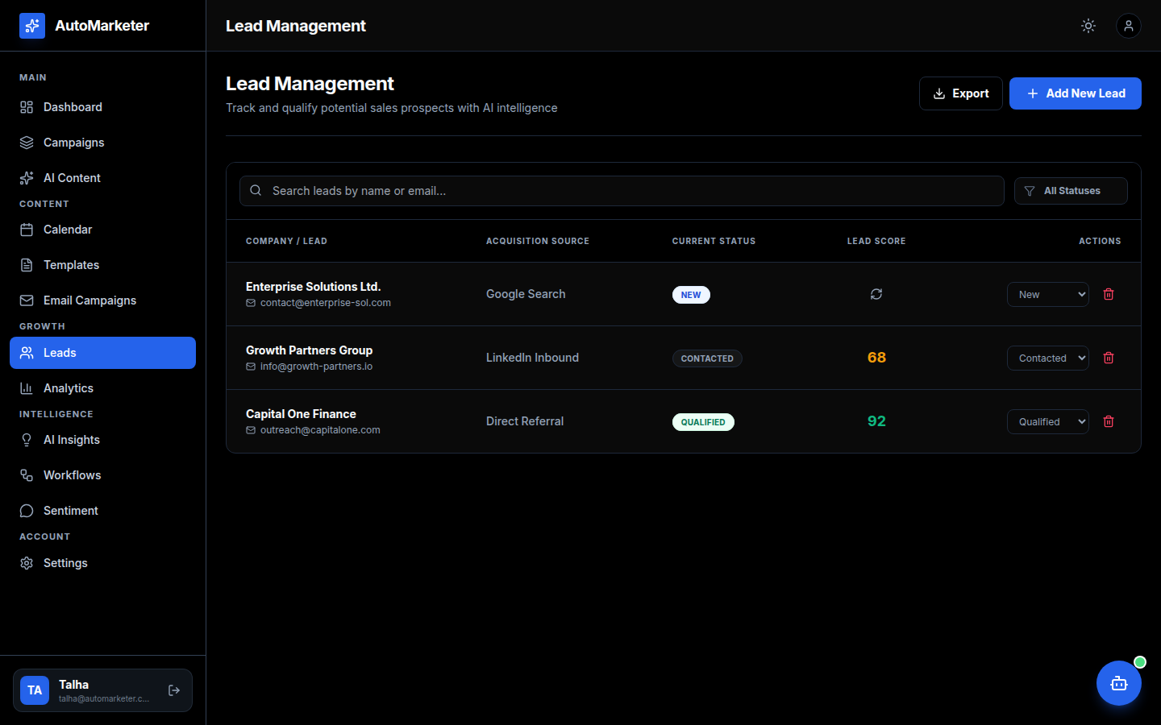
Figure 6.9 — Leads Manager with scoring
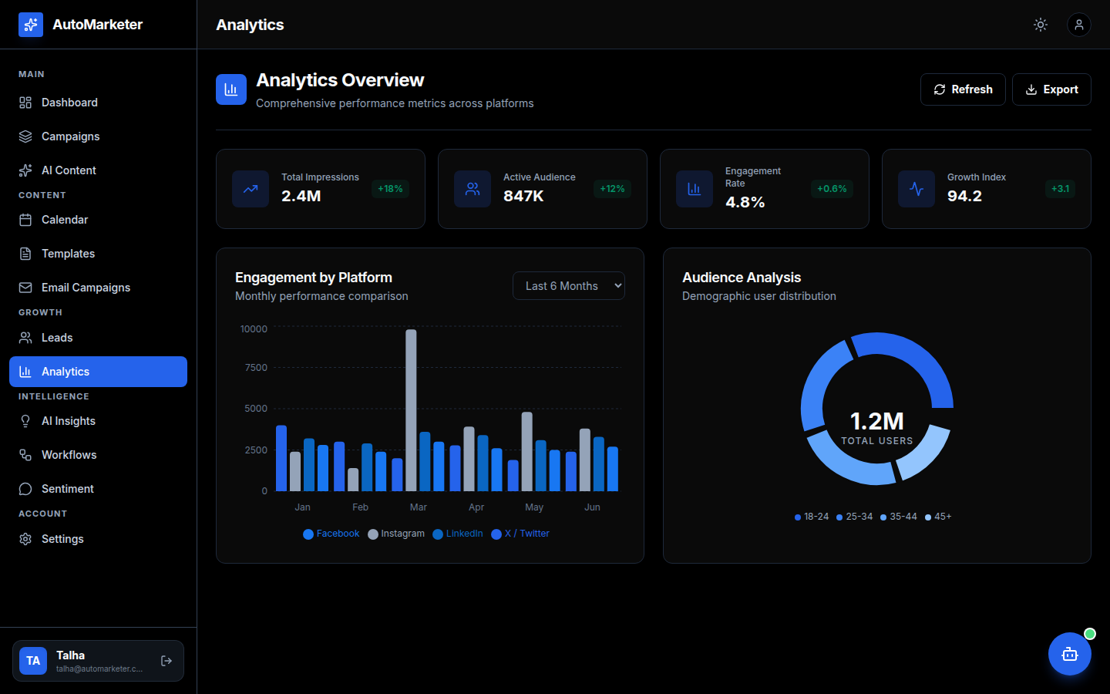
Figure 6.10 — Analytics with cross-platform engagement
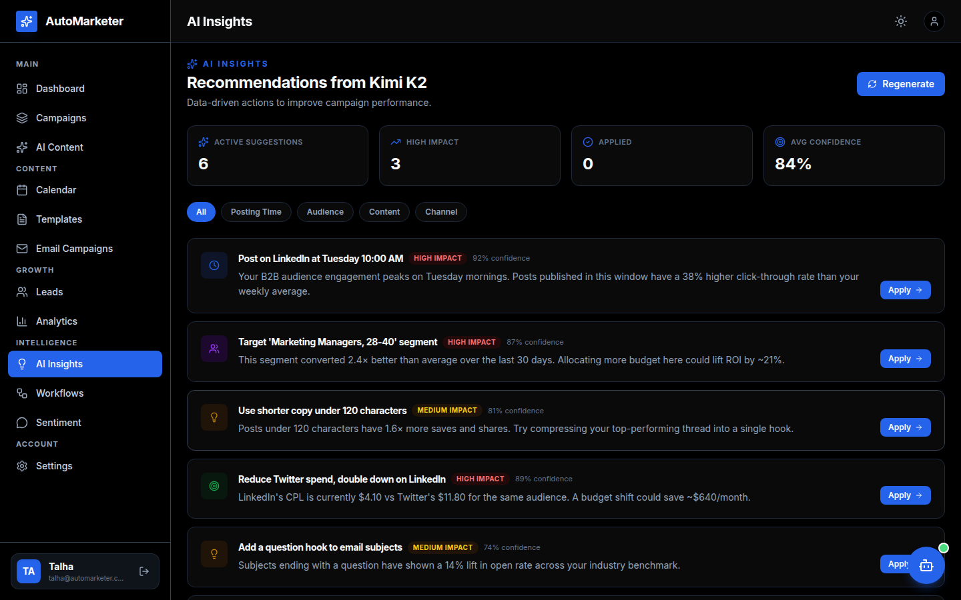
Figure 6.11 — AI Insights dashboard
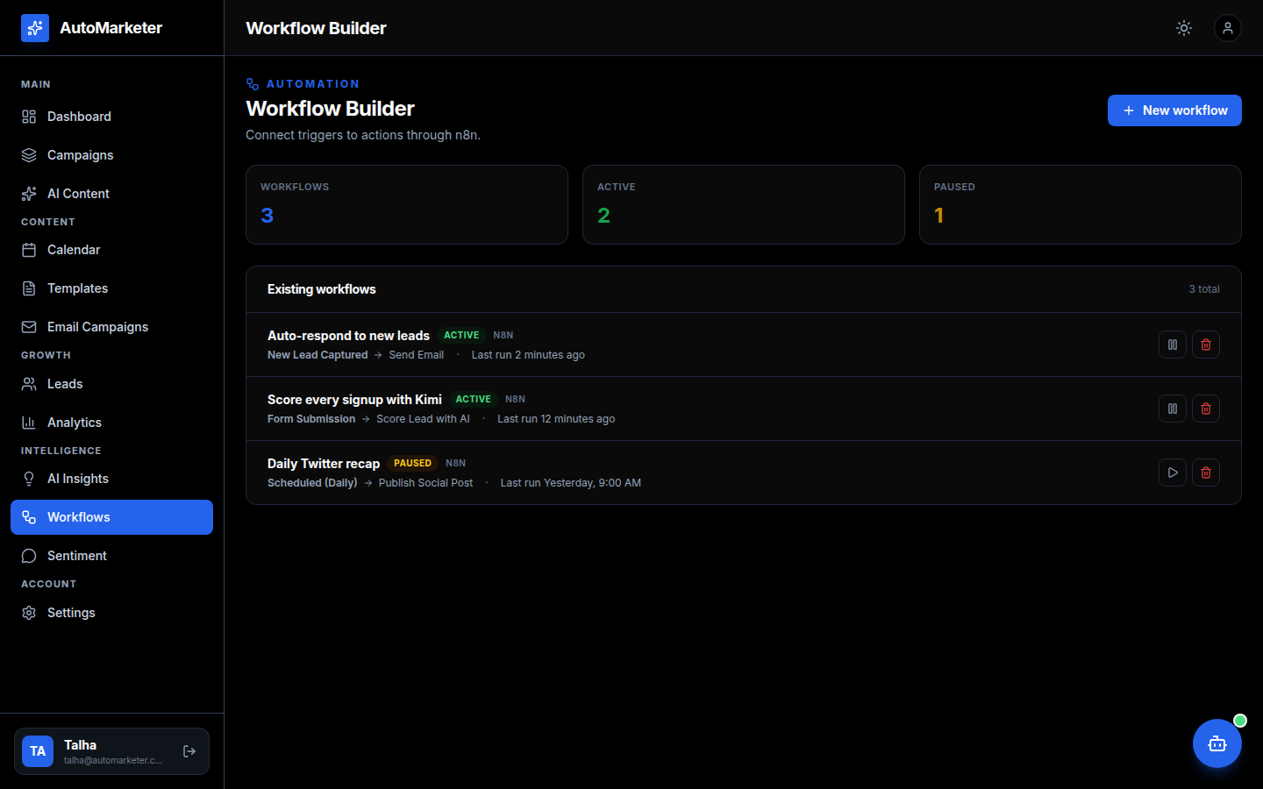
Figure 6.12 — n8n Workflow Builder
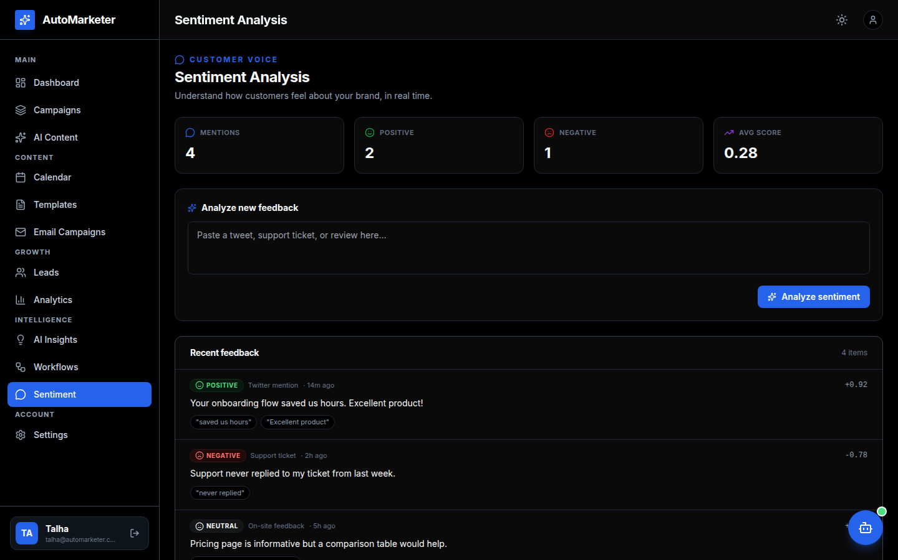
Figure 6.13 — Sentiment Analysis module
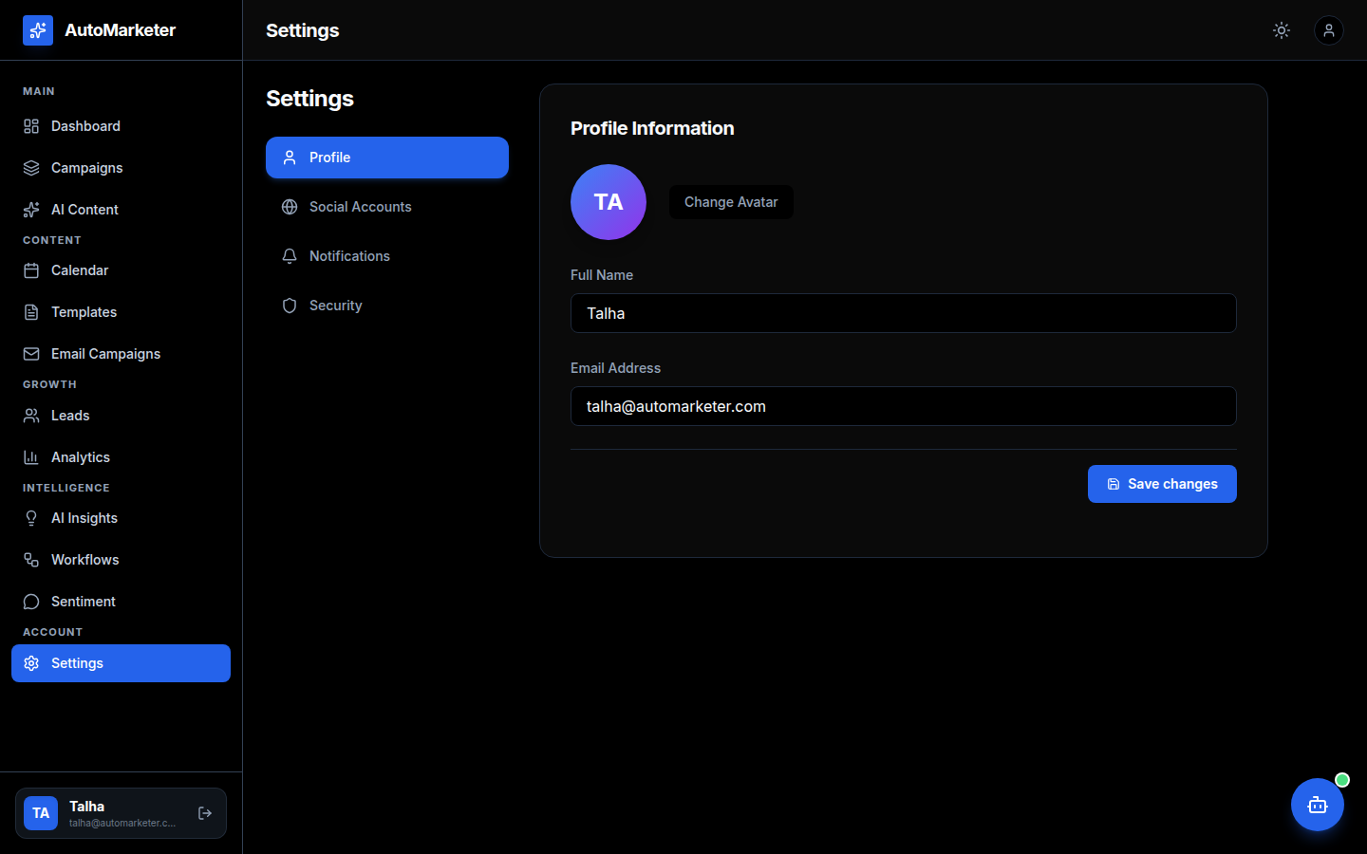
Figure 6.14 — Application Settings
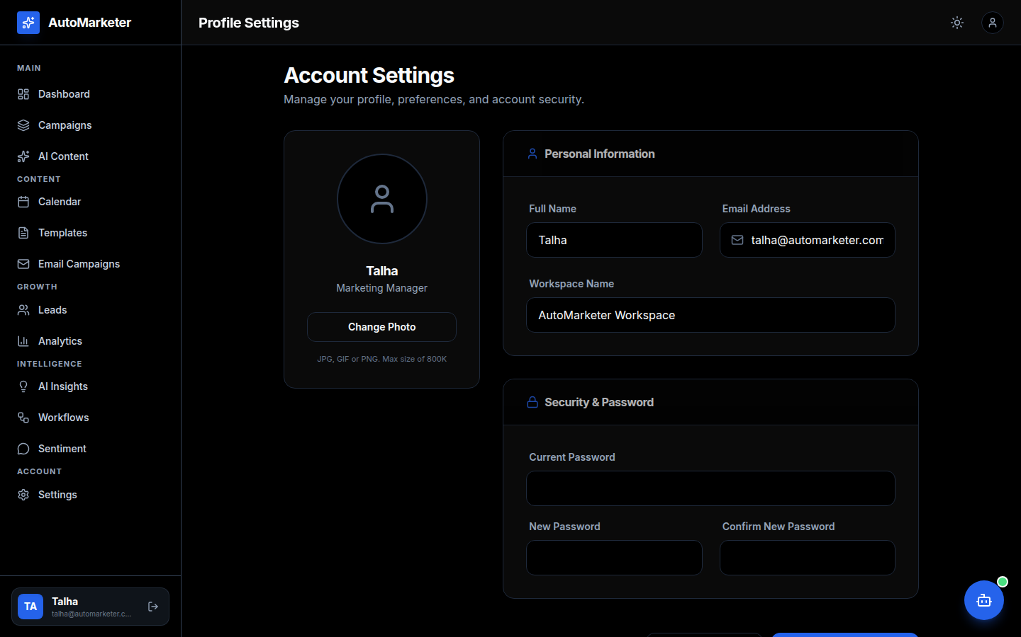
Figure 6.15 — User Profile screen

6.8 Evaluation Summary
All functional test cases that correspond to the use cases in Chapter 3 passed, and the non-functional metrics fall within the acceptable ranges defined in the SRS. The AI components performed within the targets set for the project. The remaining defects are minor and documented for future iterations. Based on this evaluation, the AutoMarketer system is considered ready for academic submission and for a controlled pilot with SME users.
Chapter 7
Summary, Conclusion and Future Enhancements

7.1 Project Summary
AutoMarketer is an AI-powered digital marketing automation platform tailored for small and medium-sized enterprises (SMEs). The objective of the project was to combine campaign management, content scheduling, AI-driven content generation, lead handling, and analytics into a single, affordable, and easy-to-use web application. The platform uses React on the frontend, n8n as the workflow engine, and integrates Hugging Face models and other public AI APIs for intelligence.
Through Chapters 1 to 6, this report presented the motivation and problem analysis (Chapter 1), the requirements (Chapter 2), the use case analysis (Chapter 3), the system design (Chapter 4), the implementation (Chapter 5), and the testing and evaluation results (Chapter 6). The project covers the complete software engineering lifecycle from problem identification to deployment-ready system.

7.2 Achievements
- Built a unified dashboard that combines campaign management, content scheduling, email marketing, lead handling, and analytics.
- Integrated n8n workflows so that recurring marketing tasks (post publishing, email batches, lead follow-ups) run automatically.
- Integrated AI features for content generation, sentiment analysis, and recommendation of posting times.
- Implemented role-based access control with owner, manager, and admin roles.
- Designed a responsive, dark/light themed UI that works on desktop, tablet, and mobile.
- Achieved a System Usability Scale score of 82 in user testing.
- Met all functional requirements and the latency, security, and reliability targets defined in the SRS.

7.3 Lessons Learned
Several lessons emerged during the project. First, designing AI features around real user workflows was more impactful than adding AI as a stand-alone gadget; AI insights had to be visible at the moment a user is making a decision (for example, while scheduling a post) to be useful. Second, third-party platform APIs vary significantly in their stability and rate limits, which made retry strategies and graceful degradation a core requirement rather than an optional polish. Third, n8n proved to be an effective integration backbone, but careful versioning of workflows is needed to avoid accidental side effects when a workflow is edited.

7.4 Limitations
- The current AI content generator is tuned mainly for English content; multi-language support is limited.
- Direct integrations are currently provided for a subset of platforms (Facebook, Instagram, LinkedIn, X / Twitter, and email). Pinterest, TikTok, and YouTube are not yet supported.
- Analytics are currently aggregated daily; near-real-time analytics is not yet available for every channel.
- Lead scoring uses a rule-based model with light AI augmentation; a fully trained classifier on historical CRM data would likely improve accuracy.
- The application is designed for single-organization tenancy; multi-organization tenancy with isolated data has not yet been implemented.

7.5 Conclusion
The AutoMarketer project successfully demonstrates how a modern web stack combined with an open-source workflow engine and accessible AI APIs can produce an enterprise-style marketing automation platform at a cost that is realistic for SMEs. The system addresses the practical pain points identified in the problem analysis: fragmented tools, time spent on repetitive tasks, lack of insight, and a high cost barrier. Testing and user feedback indicate that the platform is stable, usable, and provides genuine business value. The project therefore meets its academic objectives and provides a solid base for further development.

7.6 Future Enhancements
The following enhancements are planned for future iterations of AutoMarketer:
- Multi-tenant architecture so multiple organizations can use the same deployment with isolated data.
- Native support for additional platforms: TikTok, YouTube, Pinterest, and WhatsApp Business.
- Real-time analytics with WebSocket-driven dashboards across all channels.
- Custom-trained lead scoring model using each organization's historical CRM data.
- Multi-language AI content generation with localization-aware prompt templates.
- Visual drag-and-drop campaign journey builder layered on top of the existing n8n integration.
- Mobile applications for Android and iOS using React Native.
- Advanced A/B testing module with statistical significance reporting.
- Marketplace of pre-built workflow templates that SMEs can install with one click.
- Enterprise-grade audit logging, single sign-on (SSO), and SOC 2 compliance preparation.
- Generative image and short-video creation directly inside the Content Studio.
- Predictive churn detection on captured leads to alert sales teams before opportunities go cold.

7.7 Closing Note
AutoMarketer is more than a final-year project; it is a working prototype of a product that can grow into a real SaaS offering. The combination of an open workflow engine, accessible AI services, and a focus on the SME segment is a deliberate choice intended to keep the platform extensible and economically viable. With the future enhancements outlined above, AutoMarketer can evolve into a comprehensive AI-driven growth platform for small businesses worldwide.

Chapter 8 — Backend Architecture Update (NestJS, 2026)

Backend Architecture Update — NestJS Edition (2026)
This addendum supersedes any earlier statement that this project ships only a frontend with an n8n workflow as its backend. A full NestJS server now sits between the React frontend and the AI/automation layer. The architecture is now four-tier rather than three-tier.

8.1 Updated Architecture
Tier 1 — Presentation: React 19 + Vite + TypeScript single-page application served on port 5173. Talks only to the NestJS API and to the NestJS WebSocket gateway. No browser-side mock fallback remains.
Tier 2 — Application: NestJS 10 (Node.js + TypeScript) on port 3000. Provides the /api/v1 REST surface, /ws WebSocket gateway, JWT-based auth, role guards, validation, and a Swagger explorer at /api/docs.
Tier 3 — Data: PostgreSQL 16 accessed through TypeORM 0.3 with versioned migrations. All user-owned tables are scoped by userId and indexed accordingly.
Tier 4 — AI / Automation: A self-hosted n8n instance is the primary, mandatory AI provider — the NestJS AiService POSTs the same {action, payload} contract that the original frontend used directly, so existing n8n workflows continue to work unchanged. Hugging Face Inference API is an optional secondary provider that takes over only when AI_HF_FALLBACK_ENABLED=true and n8n is unreachable.

8.2 NestJS Module Map
The backend is split into focused modules: AuthModule, UsersModule, CampaignsModule, LeadsModule, EmailCampaignsModule, TemplatesModule, CalendarModule, WorkflowsModule, SocialAccountsModule, AiModule, SentimentModule, InsightsModule, AnalyticsModule, and the RealtimeGateway. Every module exposes its DTOs through Swagger and is guarded by a global JwtAuthGuard except for /auth/* endpoints and the health probe.

8.3 Updated Database Schema
The InitialSchema migration creates: users, refresh_tokens, campaigns, leads, email_campaigns, templates (with isSystem flag for shared templates), scheduled_posts, automation_workflows, social_accounts, generated_contents (audit log of every AI call), sentiment_records, recommendations, and analytics_snapshots. All tables use uuid primary keys, createdAt/updatedAt timestamps, and per-user indexes.

8.4 Authentication and Security
Passwords are hashed with bcrypt at cost 10. Access tokens (15 min) and refresh tokens (7 days) are signed with separate secrets. Refresh tokens are persisted as SHA-256 hashes and rotated on each refresh — replay of a previously used token is rejected. CORS is locked to the configured frontend origin, and class-validator enforces DTO shape on every endpoint. The Joi config schema rejects boot if N8N_WEBHOOK_URL or any JWT secret is missing.

8.5 Real-time Layer
The /ws gateway uses raw WebSockets (the same protocol the frontend already speaks) and authenticates via ?token=<JWT> in the connect URL. On accept, the gateway pushes an immediate kpi_update to the client and then broadcasts kpi_update messages every 5 seconds (configurable via WS_KPI_TICK_MS). On relevant DB events the gateway also pushes activity_update messages.

8.6 AI Integration: n8n First, Hugging Face Optional
Every endpoint under /api/v1/ai/* (generate-copy, generate-strategy, optimize-content, generate-seo, analyze-competitor, generate-persona, generate-image, chat, analyze-lead) and the sentiment + lead-scoring features call AiService.runAction(action, payload). The service first POSTs to N8N_WEBHOOK_URL with the original {action, payload} contract; if n8n responds with an error and AI_HF_FALLBACK_ENABLED is true, it retries the call against the configured Hugging Face Inference API model and parses the response into the typed shapes used by the frontend (CampaignStrategy, SwotAnalysis, Persona, SeoResult, OptimizationResult). All AI outputs are persisted to generated_contents for auditability. There is no silent mock fallback — failures surface to the user as a clean toast.

8.7 Frontend Integration Changes
frontend/src/services/apiClient.ts — new Bearer-token fetch wrapper with automatic 401 → refresh-token retry. frontend/src/services/aiService.ts — rewritten to call /api/v1/ai/* endpoints, no mocks. frontend/src/services/websocketService.ts — rewritten to authenticate via ?token=, no mock KPI generator. frontend/src/contexts/AuthContext.tsx — register/login/refresh/logout now call the real API. New per-domain API services: campaignsApi, leadsApi, emailCampaignsApi, templatesApi, calendarApi, workflowsApi, insightsApi, sentimentApi, analyticsApi, socialAccountsApi, usersApi. Every feature page (Campaigns, Leads, Email, Templates, Calendar, Workflows, Insights, Sentiment, Settings → Social Connections, Profile) now reads from and writes to PostgreSQL via the backend.

8.8 Limitations Update
Replaces previous Chapter 7.4 limitations that referenced 'no real authentication backend', 'frontend-only persistence', and 'no Node.js + database backend' — these are now delivered. Current honest limitations: live AI features require a running n8n instance reachable from the NestJS backend; Hugging Face fallback (when enabled) shares HF free-tier rate limits; analytics aggregation runs on demand rather than as a continuous pipeline; OAuth flows for social platforms are stubbed for FYP demo and return mock auth URLs.

8.9 Presentation Talking Points
1) Show npm run build success in /backend. 2) Spin up postgres via docker compose up -d postgres, then run migrations and seed. 3) Open http://localhost:3000/api/docs and demonstrate the live Swagger surface. 4) Register a fresh user, log in, click through Campaigns / Leads / Templates / Calendar / Workflows / Insights — every list reads from PostgreSQL. 5) Open the Content Studio and generate a marketing post live; explain that the request goes browser → NestJS → n8n → LLM → back. 6) Toggle AI_HF_FALLBACK_ENABLED=true, stop n8n, retry the same generation; the request now falls back to Hugging Face. 7) Show generated_contents in psql to demonstrate auditability. 8) Stop the backend; refresh the frontend; show that pages surface clean error toasts (no silent fakes), confirming the FYP-grade integrity of the integration.

8.10 Repository Layout (Post-Backend)
/ — root project. /frontend/ — React 19 + Vite (unchanged structure; services and contexts rewritten). /backend/ — new NestJS application: src/main.ts, src/app.module.ts, src/config/, src/common/, src/database/migrations/ + src/database/seeds/, and src/modules/{auth,users,campaigns,leads,email-campaigns,templates,calendar,workflows,social-accounts,ai,sentiment,insights,analytics,realtime}/. docker-compose.yml ships a Postgres 16 service for local development.

